

**21/12/19**

**Q1**

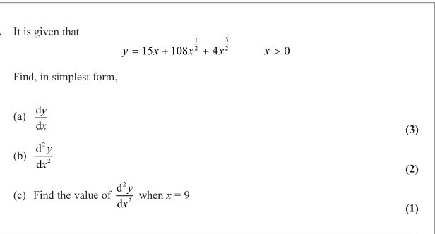

**…………………………………………………………………………………………………………**

**…………………………………………………………………………………………………………**

**…………………………………………………………………………………………………………**

**…………………………………………………………………………………………………………**

**…………………………………………………………………………………………………………**

**…………………………………………………………………………………………………………**

**…………………………………………………………………………………………………………**

**…………………………………………………………………………………………………………**

**…………………………………………………………………………………………………………**

**…………………………………………………………………………………………………………**

**…………………………………………………………………………………………………………**

**…………………………………………………………………………………………………………**

**…………………………………………………………………………………………………………**

**…………………………………………………………………………………………………………**

**…………………………………………………………………………………………………………**

**…………………………………………………………………………………………………………**

**…………………………………………………………………………………………………………**

**…………………………………………………………………………………………………………**

**…………………………………………………………………………………………………………**

**…………………………………………………………………………………………………………**

**…………………………………………………………………………………………………………**

**…………………………………………………………………………………………………………**

**…………………………………………………………………………………………………………**

**…………………………………………………………………………………………………………**

**…………………………………………………………………………………………………………**

**…………………………………………………………………………………………………………**

**…………………………………………………………………………………………………………**

**…………………………………………………………………………………………………………**

**…………………………………………………………………………………………………………**

**…………………………………………………………………………………………………………**

**…………………………………………………………………………………………………………**

**Q2**

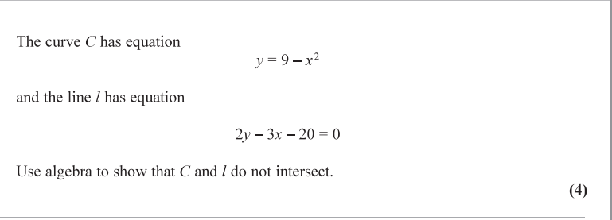

**…………………………………………………………………………………………………………**

**…………………………………………………………………………………………………………**

**…………………………………………………………………………………………………………**

**…………………………………………………………………………………………………………**

**…………………………………………………………………………………………………………**

**…………………………………………………………………………………………………………**

**…………………………………………………………………………………………………………**

**…………………………………………………………………………………………………………**

**…………………………………………………………………………………………………………**

**…………………………………………………………………………………………………………**

**…………………………………………………………………………………………………………**

**…………………………………………………………………………………………………………**

**…………………………………………………………………………………………………………**

**…………………………………………………………………………………………………………**

**…………………………………………………………………………………………………………**

**…………………………………………………………………………………………………………**

**…………………………………………………………………………………………………………**

**…………………………………………………………………………………………………………**

**…………………………………………………………………………………………………………**

**…………………………………………………………………………………………………………**

**…………………………………………………………………………………………………………**

**…………………………………………………………………………………………………………**

**…………………………………………………………………………………………………………**

**…………………………………………………………………………………………………………**

**…………………………………………………………………………………………………………**

**…………………………………………………………………………………………………………**

**…………………………………………………………………………………………………………**

**…………………………………………………………………………………………………………**

**…………………………………………………………………………………………………………**

**…………………………………………………………………………………………………………**

**…………………………………………………………………………………………………………**

**…………………………………………………………………………………………………………**

**…………………………………………………………………………………………………………**

**…………………………………………………………………………………………………………**

**…………………………………………………………………………………………………………**

**Q3**

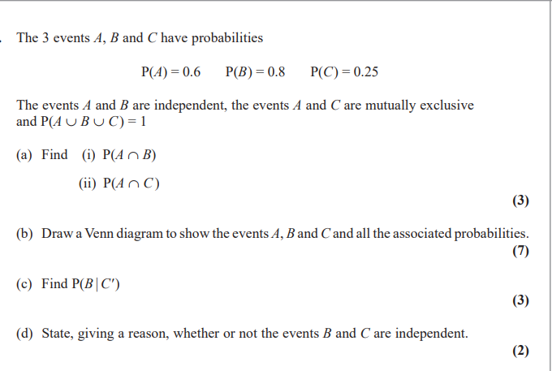

**…………………………………………………………………………………………………………**

**…………………………………………………………………………………………………………**

**…………………………………………………………………………………………………………**

**…………………………………………………………………………………………………………**

**…………………………………………………………………………………………………………**

**…………………………………………………………………………………………………………**

**…………………………………………………………………………………………………………**

**…………………………………………………………………………………………………………**

**…………………………………………………………………………………………………………**

**…………………………………………………………………………………………………………**

**…………………………………………………………………………………………………………**

**…………………………………………………………………………………………………………**

**…………………………………………………………………………………………………………**

**…………………………………………………………………………………………………………**

**…………………………………………………………………………………………………………**

**…………………………………………………………………………………………………………**

**…………………………………………………………………………………………………………**

**…………………………………………………………………………………………………………**

**…………………………………………………………………………………………………………**

**…………………………………………………………………………………………………………**

**…………………………………………………………………………………………………………**

**…………………………………………………………………………………………………………**

**…………………………………………………………………………………………………………**

**…………………………………………………………………………………………………………**

**…………………………………………………………………………………………………………**

**…………………………………………………………………………………………………………**

**…………………………………………………………………………………………………………**

**…………………………………………………………………………………………………………**

**…………………………………………………………………………………………………………**

**…………………………………………………………………………………………………………**

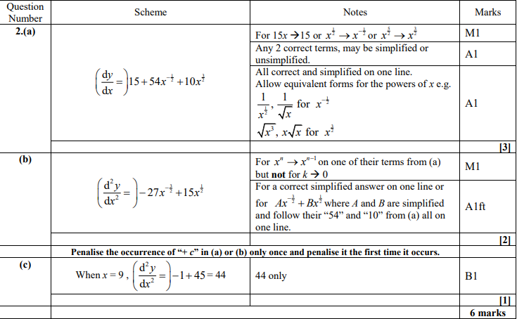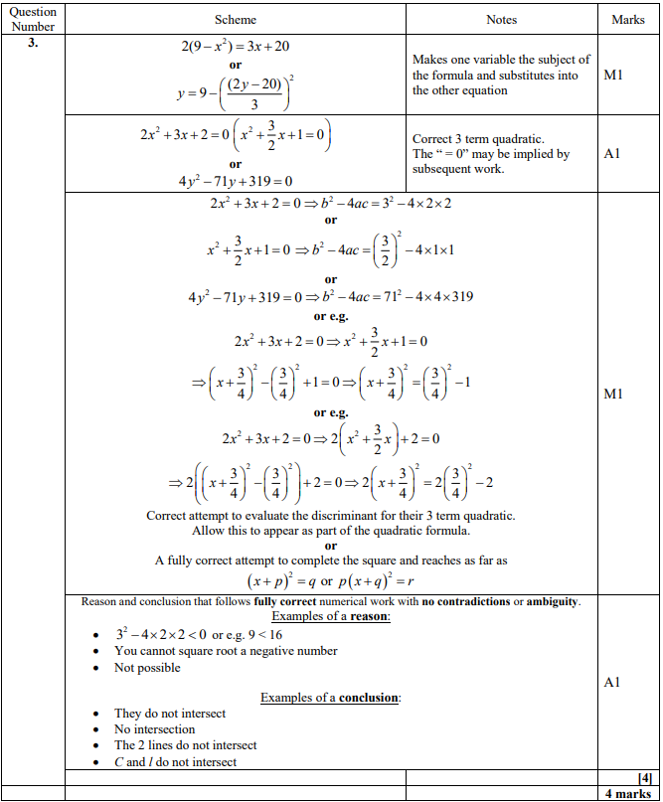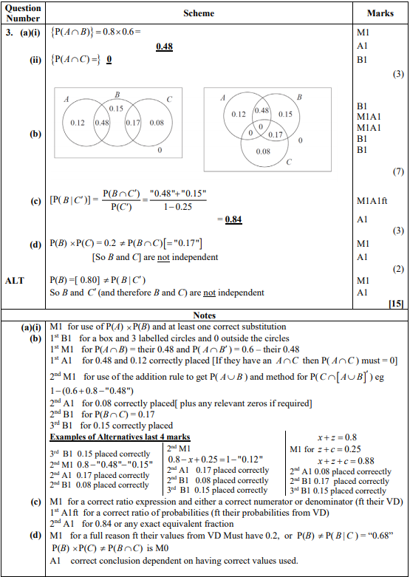

**22/12/19**

**Q4**

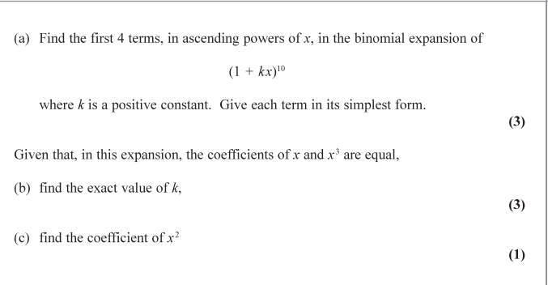

**…………………………………………………………………………………………………………**

**…………………………………………………………………………………………………………**

**…………………………………………………………………………………………………………**

**…………………………………………………………………………………………………………**

**…………………………………………………………………………………………………………**

**…………………………………………………………………………………………………………**

**…………………………………………………………………………………………………………**

**…………………………………………………………………………………………………………**

**…………………………………………………………………………………………………………**

**…………………………………………………………………………………………………………**

**…………………………………………………………………………………………………………**

**…………………………………………………………………………………………………………**

**…………………………………………………………………………………………………………**

**…………………………………………………………………………………………………………**

**…………………………………………………………………………………………………………**

**…………………………………………………………………………………………………………**

**…………………………………………………………………………………………………………**

**…………………………………………………………………………………………………………**

**…………………………………………………………………………………………………………**

**…………………………………………………………………………………………………………**

**…………………………………………………………………………………………………………**

**…………………………………………………………………………………………………………**

**…………………………………………………………………………………………………………**

**…………………………………………………………………………………………………………**

**…………………………………………………………………………………………………………**

**…………………………………………………………………………………………………………**

**…………………………………………………………………………………………………………**

**…………………………………………………………………………………………………………**

**…………………………………………………………………………………………………………**

**…………………………………………………………………………………………………………**

**…………………………………………………………………………………………………………**

**Q5**

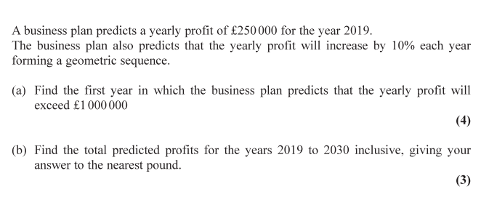

**…………………………………………………………………………………………………………**

**…………………………………………………………………………………………………………**

**…………………………………………………………………………………………………………**

**…………………………………………………………………………………………………………**

**…………………………………………………………………………………………………………**

**…………………………………………………………………………………………………………**

**…………………………………………………………………………………………………………**

**…………………………………………………………………………………………………………**

**…………………………………………………………………………………………………………**

**…………………………………………………………………………………………………………**

**…………………………………………………………………………………………………………**

**…………………………………………………………………………………………………………**

**…………………………………………………………………………………………………………**

**…………………………………………………………………………………………………………**

**…………………………………………………………………………………………………………**

**…………………………………………………………………………………………………………**

**…………………………………………………………………………………………………………**

**…………………………………………………………………………………………………………**

**…………………………………………………………………………………………………………**

**…………………………………………………………………………………………………………**

**…………………………………………………………………………………………………………**

**…………………………………………………………………………………………………………**

**…………………………………………………………………………………………………………**

**…………………………………………………………………………………………………………**

**…………………………………………………………………………………………………………**

**…………………………………………………………………………………………………………**

**…………………………………………………………………………………………………………**

**…………………………………………………………………………………………………………**

**…………………………………………………………………………………………………………**

**…………………………………………………………………………………………………………**

**…………………………………………………………………………………………………………**

**…………………………………………………………………………………………………………**

**…………………………………………………………………………………………………………**

**Q6**

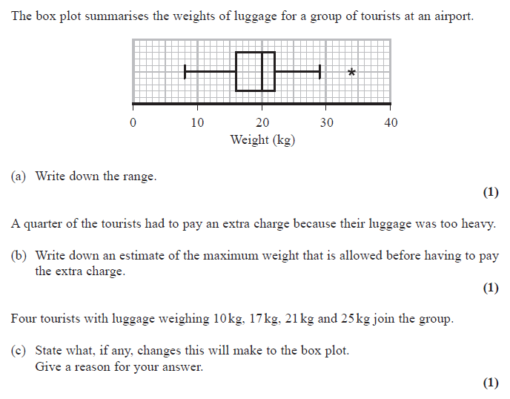

**…………………………………………………………………………………………………………**

**…………………………………………………………………………………………………………**

**…………………………………………………………………………………………………………**

**…………………………………………………………………………………………………………**

**…………………………………………………………………………………………………………**

**…………………………………………………………………………………………………………**

**…………………………………………………………………………………………………………**

**…………………………………………………………………………………………………………**

**…………………………………………………………………………………………………………**

**…………………………………………………………………………………………………………**

**…………………………………………………………………………………………………………**

**…………………………………………………………………………………………………………**

**…………………………………………………………………………………………………………**

**…………………………………………………………………………………………………………**

**…………………………………………………………………………………………………………**

**…………………………………………………………………………………………………………**

**…………………………………………………………………………………………………………**

**…………………………………………………………………………………………………………**

**…………………………………………………………………………………………………………**

**…………………………………………………………………………………………………………**

**…………………………………………………………………………………………………………**

**…………………………………………………………………………………………………………**

**…………………………………………………………………………………………………………**

**…………………………………………………………………………………………………………**

**…………………………………………………………………………………………………………**

**…………………………………………………………………………………………………………**

**…………………………………………………………………………………………………………**

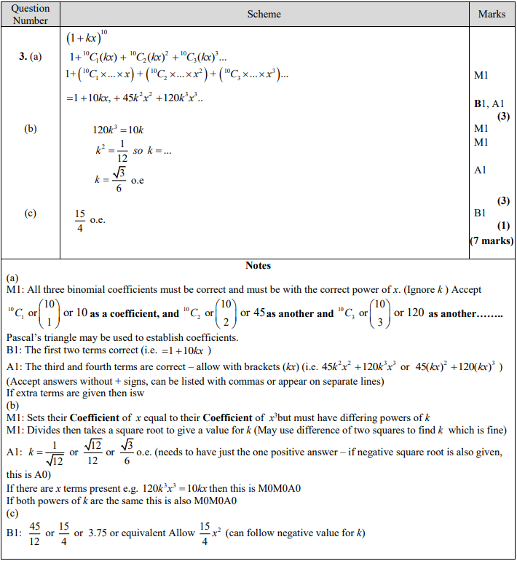

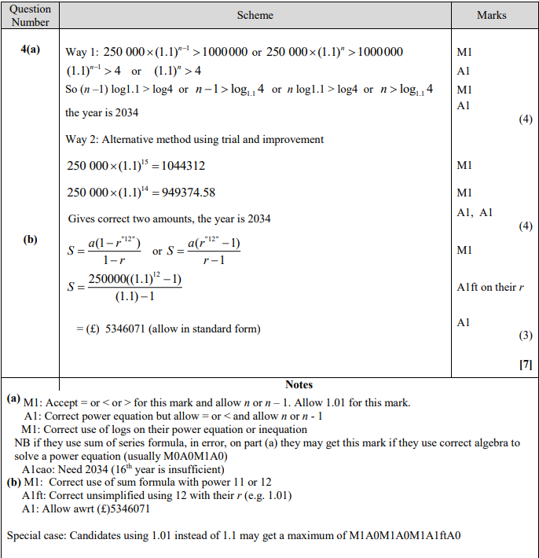

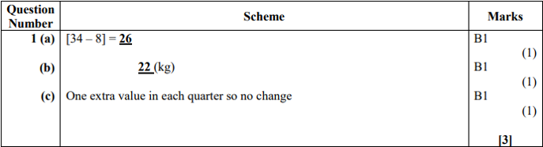

**23/12/19**

**Q7**

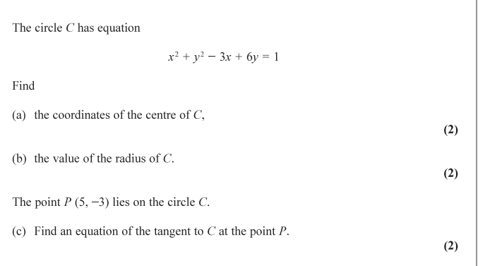

**…………………………………………………………………………………………………………**

**…………………………………………………………………………………………………………**

**…………………………………………………………………………………………………………**

**…………………………………………………………………………………………………………**

**…………………………………………………………………………………………………………**

**…………………………………………………………………………………………………………**

**…………………………………………………………………………………………………………**

**…………………………………………………………………………………………………………**

**…………………………………………………………………………………………………………**

**…………………………………………………………………………………………………………**

**…………………………………………………………………………………………………………**

**…………………………………………………………………………………………………………**

**…………………………………………………………………………………………………………**

**…………………………………………………………………………………………………………**

**…………………………………………………………………………………………………………**

**…………………………………………………………………………………………………………**

**…………………………………………………………………………………………………………**

**…………………………………………………………………………………………………………**

**…………………………………………………………………………………………………………**

**…………………………………………………………………………………………………………**

**…………………………………………………………………………………………………………**

**…………………………………………………………………………………………………………**

**…………………………………………………………………………………………………………**

**…………………………………………………………………………………………………………**

**…………………………………………………………………………………………………………**

**…………………………………………………………………………………………………………**

**…………………………………………………………………………………………………………**

**…………………………………………………………………………………………………………**

**…………………………………………………………………………………………………………**

**…………………………………………………………………………………………………………**

**Q8**

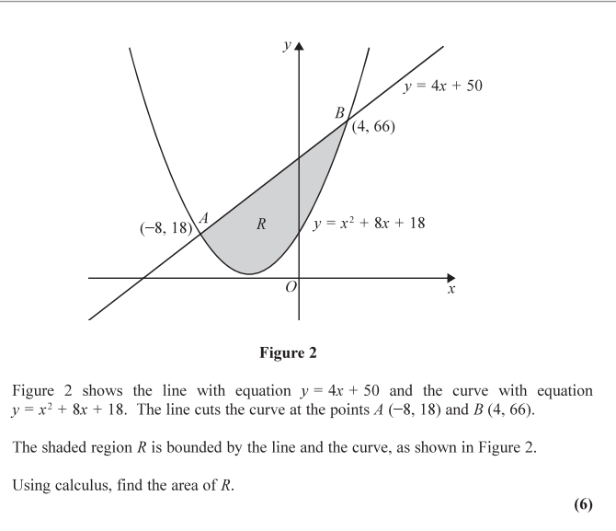

**…………………………………………………………………………………………………………**

**…………………………………………………………………………………………………………**

**…………………………………………………………………………………………………………**

**…………………………………………………………………………………………………………**

**…………………………………………………………………………………………………………**

**…………………………………………………………………………………………………………**

**…………………………………………………………………………………………………………**

**…………………………………………………………………………………………………………**

**…………………………………………………………………………………………………………**

**…………………………………………………………………………………………………………**

**…………………………………………………………………………………………………………**

**…………………………………………………………………………………………………………**

**…………………………………………………………………………………………………………**

**…………………………………………………………………………………………………………**

**…………………………………………………………………………………………………………**

**…………………………………………………………………………………………………………**

**…………………………………………………………………………………………………………**

**…………………………………………………………………………………………………………**

**…………………………………………………………………………………………………………**

**…………………………………………………………………………………………………………**

**…………………………………………………………………………………………………………**

**…………………………………………………………………………………………………………**

**…………………………………………………………………………………………………………**

**…………………………………………………………………………………………………………**

**…………………………………………………………………………………………………………**

**…………………………………………………………………………………………………………**

**Q9**

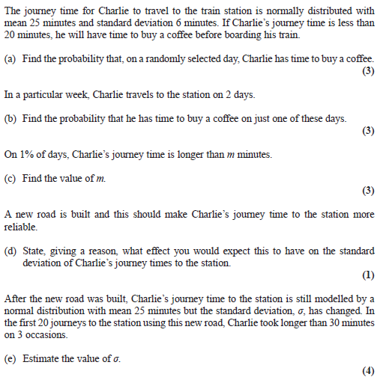

**…………………………………………………………………………………………………………**

**…………………………………………………………………………………………………………**

**…………………………………………………………………………………………………………**

**…………………………………………………………………………………………………………**

**…………………………………………………………………………………………………………**

**…………………………………………………………………………………………………………**

**…………………………………………………………………………………………………………**

**…………………………………………………………………………………………………………**

**…………………………………………………………………………………………………………**

**…………………………………………………………………………………………………………**

**…………………………………………………………………………………………………………**

**…………………………………………………………………………………………………………**

**…………………………………………………………………………………………………………**

**…………………………………………………………………………………………………………**

**…………………………………………………………………………………………………………**

**…………………………………………………………………………………………………………**

**…………………………………………………………………………………………………………**

**…………………………………………………………………………………………………………**

**…………………………………………………………………………………………………………**

**…………………………………………………………………………………………………………**

**…………………………………………………………………………………………………………**

**…………………………………………………………………………………………………………**

**…………………………………………………………………………………………………………**

**…………………………………………………………………………………………………………**

**…………………………………………………………………………………………………………**

**…………………………………………………………………………………………………………**

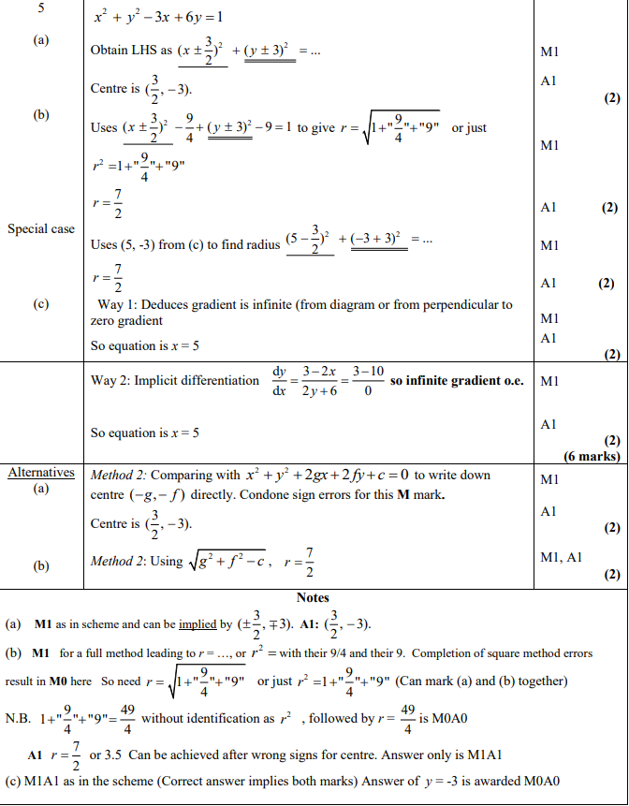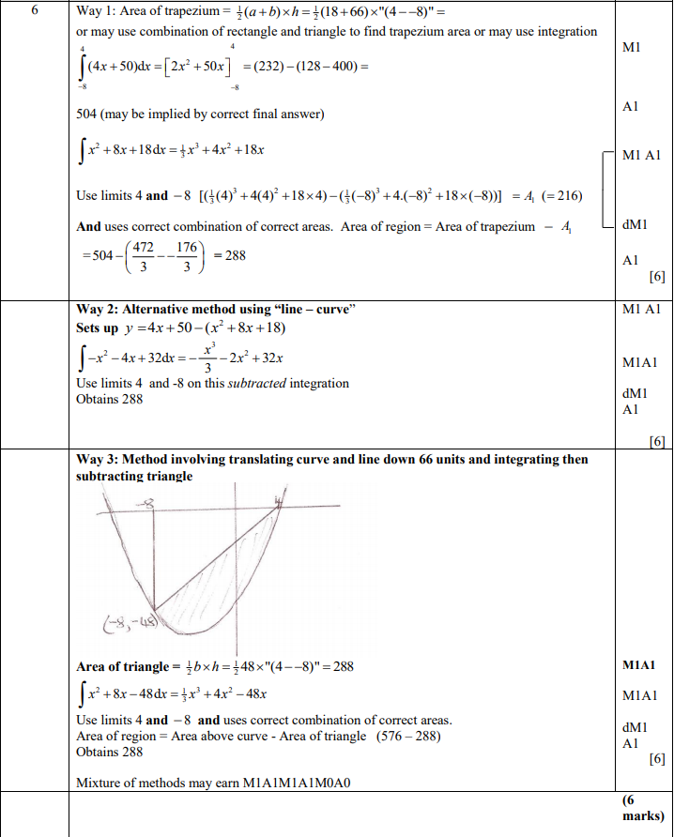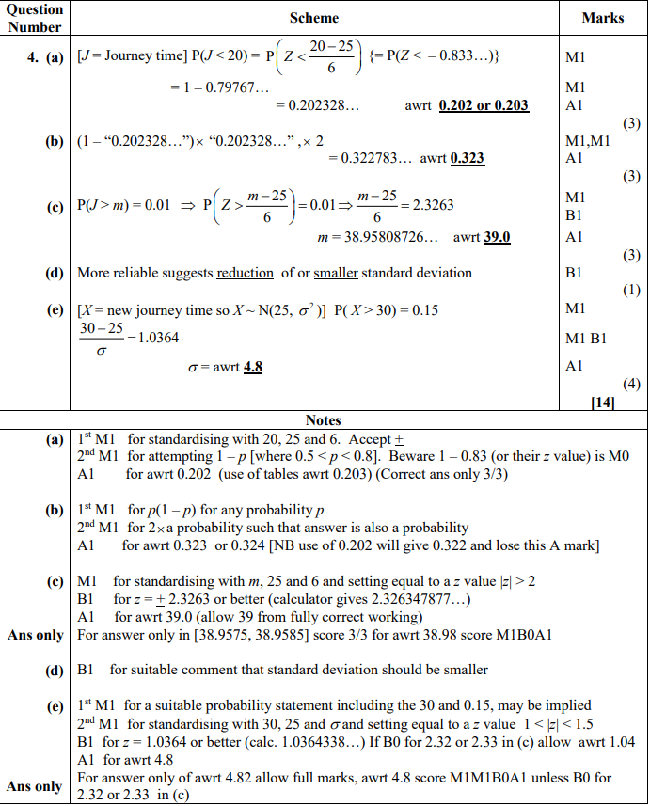

**24/12/19**

**Q10**

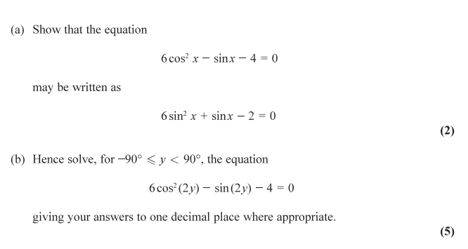

**…………………………………………………………………………………………………………**

**…………………………………………………………………………………………………………**

**…………………………………………………………………………………………………………**

**…………………………………………………………………………………………………………**

**…………………………………………………………………………………………………………**

**…………………………………………………………………………………………………………**

**…………………………………………………………………………………………………………**

**…………………………………………………………………………………………………………**

**…………………………………………………………………………………………………………**

**…………………………………………………………………………………………………………**

**…………………………………………………………………………………………………………**

**…………………………………………………………………………………………………………**

**…………………………………………………………………………………………………………**

**…………………………………………………………………………………………………………**

**…………………………………………………………………………………………………………**

**…………………………………………………………………………………………………………**

**…………………………………………………………………………………………………………**

**…………………………………………………………………………………………………………**

**…………………………………………………………………………………………………………**

**…………………………………………………………………………………………………………**

**…………………………………………………………………………………………………………**

**…………………………………………………………………………………………………………**

**…………………………………………………………………………………………………………**

**…………………………………………………………………………………………………………**

**…………………………………………………………………………………………………………**

**…………………………………………………………………………………………………………**

**…………………………………………………………………………………………………………**

**…………………………………………………………………………………………………………**

**…………………………………………………………………………………………………………**

**…………………………………………………………………………………………………………**

**…………………………………………………………………………………………………………**

**Q11**

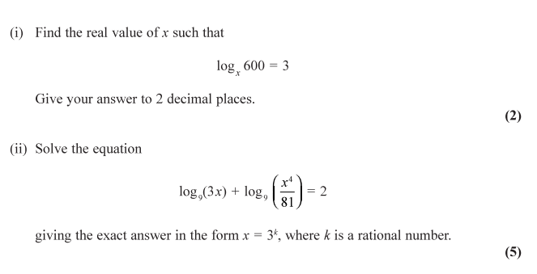

**…………………………………………………………………………………………………………**

**…………………………………………………………………………………………………………**

**…………………………………………………………………………………………………………**

**…………………………………………………………………………………………………………**

**…………………………………………………………………………………………………………**

**…………………………………………………………………………………………………………**

**…………………………………………………………………………………………………………**

**…………………………………………………………………………………………………………**

**…………………………………………………………………………………………………………**

**…………………………………………………………………………………………………………**

**…………………………………………………………………………………………………………**

**…………………………………………………………………………………………………………**

**…………………………………………………………………………………………………………**

**…………………………………………………………………………………………………………**

**…………………………………………………………………………………………………………**

**…………………………………………………………………………………………………………**

**…………………………………………………………………………………………………………**

**…………………………………………………………………………………………………………**

**…………………………………………………………………………………………………………**

**…………………………………………………………………………………………………………**

**…………………………………………………………………………………………………………**

**…………………………………………………………………………………………………………**

**…………………………………………………………………………………………………………**

**…………………………………………………………………………………………………………**

**…………………………………………………………………………………………………………**

**…………………………………………………………………………………………………………**

**…………………………………………………………………………………………………………**

**…………………………………………………………………………………………………………**

**…………………………………………………………………………………………………………**

**…………………………………………………………………………………………………………**

**…………………………………………………………………………………………………………**

**…………………………………………………………………………………………………………**

**…………………………………………………………………………………………………………**

**Q12**

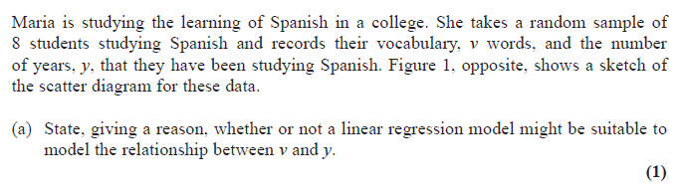

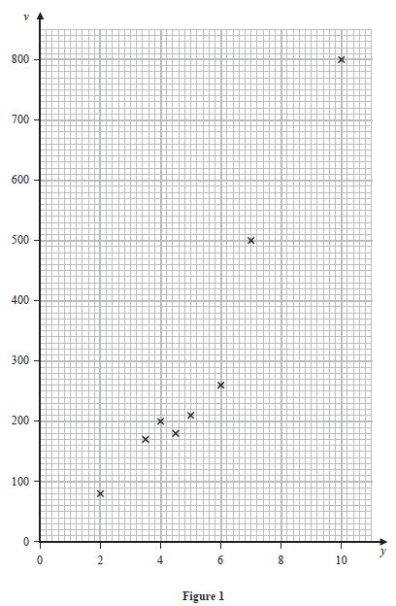

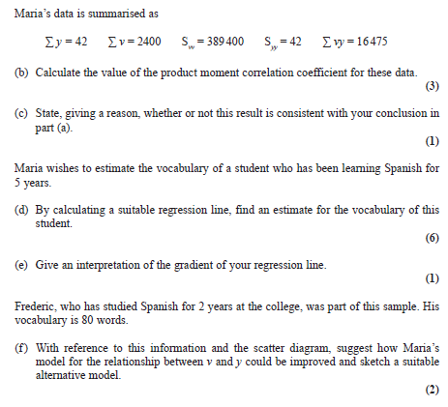

**…………………………………………………………………………………………………………**

**…………………………………………………………………………………………………………**

**…………………………………………………………………………………………………………**

**…………………………………………………………………………………………………………**

**…………………………………………………………………………………………………………**

**…………………………………………………………………………………………………………**

**…………………………………………………………………………………………………………**

**…………………………………………………………………………………………………………**

**…………………………………………………………………………………………………………**

**…………………………………………………………………………………………………………**

**…………………………………………………………………………………………………………**

**…………………………………………………………………………………………………………**

**…………………………………………………………………………………………………………**

**…………………………………………………………………………………………………………**

**…………………………………………………………………………………………………………**

**…………………………………………………………………………………………………………**

**…………………………………………………………………………………………………………**

**…………………………………………………………………………………………………………**

**…………………………………………………………………………………………………………**

**…………………………………………………………………………………………………………**

**…………………………………………………………………………………………………………**

**…………………………………………………………………………………………………………**

**…………………………………………………………………………………………………………**

**…………………………………………………………………………………………………………**

**…………………………………………………………………………………………………………**

**…………………………………………………………………………………………………………**

**…………………………………………………………………………………………………………**

**…………………………………………………………………………………………………………**

**…………………………………………………………………………………………………………**

**…………………………………………………………………………………………………………**

**…………………………………………………………………………………………………………**

**…………………………………………………………………………………………………………**

**…………………………………………………………………………………………………………**

**…………………………………………………………………………………………………………**

**…………………………………………………………………………………………………………**

**…………………………………………………………………………………………………………**

**…………………………………………………………………………………………………………**

**…………………………………………………………………………………………………………**

**…………………………………………………………………………………………………………**

**…………………………………………………………………………………………………………**

**…………………………………………………………………………………………………………**

**…………………………………………………………………………………………………………**

**…………………………………………………………………………………………………………**

**…………………………………………………………………………………………………………**

**…………………………………………………………………………………………………………**

**…………………………………………………………………………………………………………**

**…………………………………………………………………………………………………………**

**…………………………………………………………………………………………………………**

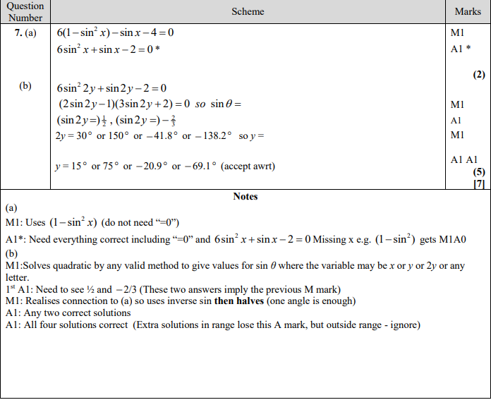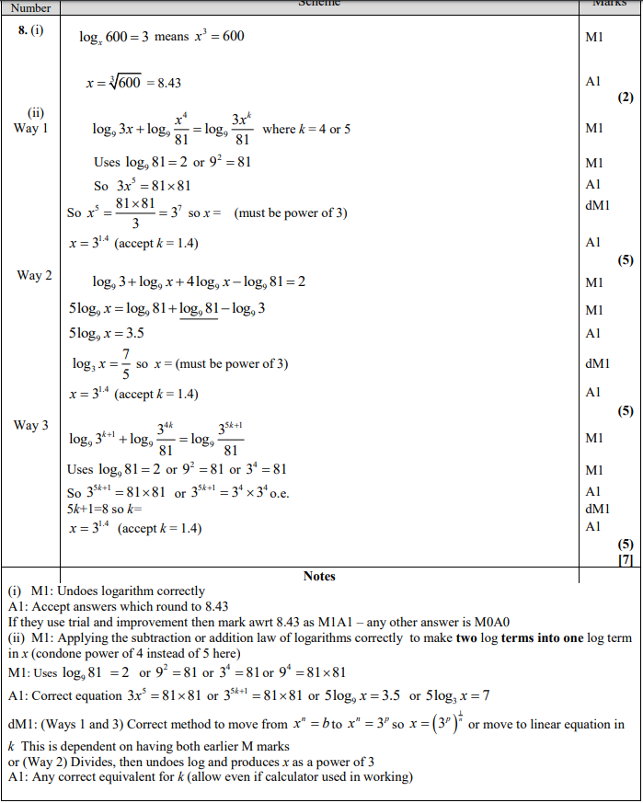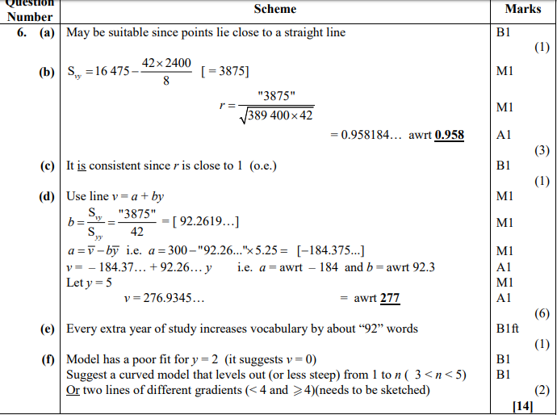

**26/12/19**

**Q13**

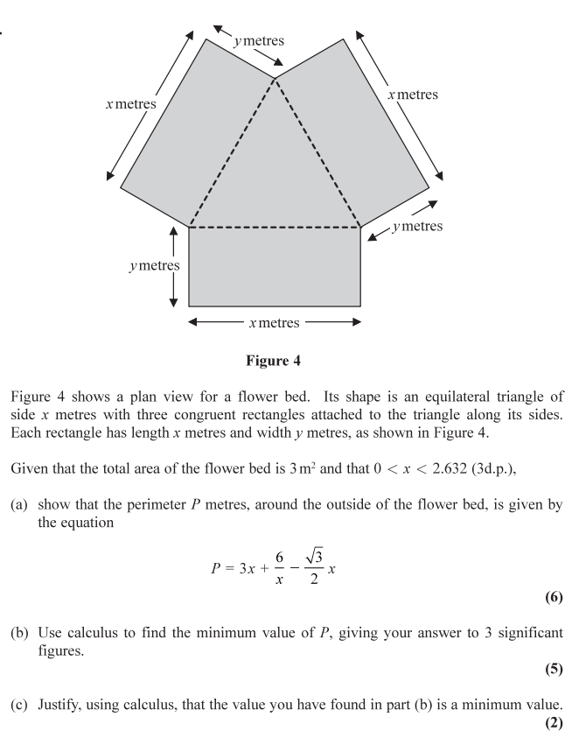

**…………………………………………………………………………………………………………**

**…………………………………………………………………………………………………………**

**…………………………………………………………………………………………………………**

**…………………………………………………………………………………………………………**

**…………………………………………………………………………………………………………**

**…………………………………………………………………………………………………………**

**…………………………………………………………………………………………………………**

**…………………………………………………………………………………………………………**

**…………………………………………………………………………………………………………**

**…………………………………………………………………………………………………………**

**…………………………………………………………………………………………………………**

**…………………………………………………………………………………………………………**

**…………………………………………………………………………………………………………**

**…………………………………………………………………………………………………………**

**…………………………………………………………………………………………………………**

**…………………………………………………………………………………………………………**

**…………………………………………………………………………………………………………**

**…………………………………………………………………………………………………………**

**…………………………………………………………………………………………………………**

**…………………………………………………………………………………………………………**

**…………………………………………………………………………………………………………**

**…………………………………………………………………………………………………………**

**…………………………………………………………………………………………………………**

**Q14**

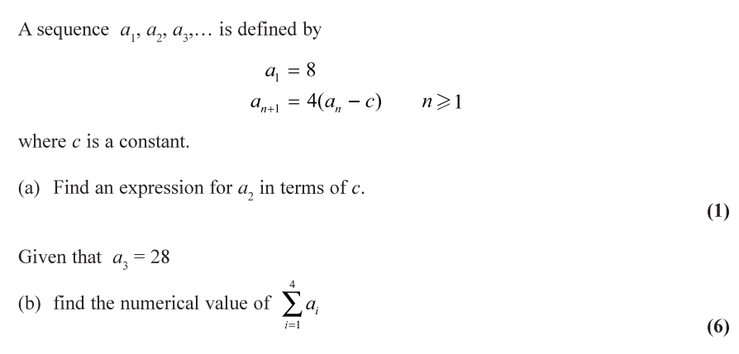

**…………………………………………………………………………………………………………**

**…………………………………………………………………………………………………………**

**…………………………………………………………………………………………………………**

**…………………………………………………………………………………………………………**

**…………………………………………………………………………………………………………**

**…………………………………………………………………………………………………………**

**…………………………………………………………………………………………………………**

**…………………………………………………………………………………………………………**

**…………………………………………………………………………………………………………**

**…………………………………………………………………………………………………………**

**…………………………………………………………………………………………………………**

**…………………………………………………………………………………………………………**

**…………………………………………………………………………………………………………**

**…………………………………………………………………………………………………………**

**…………………………………………………………………………………………………………**

**…………………………………………………………………………………………………………**

**…………………………………………………………………………………………………………**

**…………………………………………………………………………………………………………**

**…………………………………………………………………………………………………………**

**…………………………………………………………………………………………………………**

**…………………………………………………………………………………………………………**

**…………………………………………………………………………………………………………**

**…………………………………………………………………………………………………………**

**…………………………………………………………………………………………………………**

**…………………………………………………………………………………………………………**

**…………………………………………………………………………………………………………**

**…………………………………………………………………………………………………………**

**…………………………………………………………………………………………………………**

**…………………………………………………………………………………………………………**

**…………………………………………………………………………………………………………**

**…………………………………………………………………………………………………………**

**…………………………………………………………………………………………………………**

**Q15**

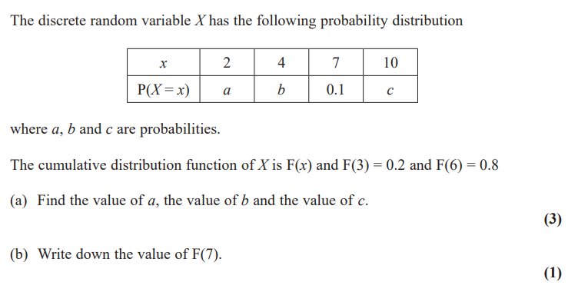

**…………………………………………………………………………………………………………**

**…………………………………………………………………………………………………………**

**…………………………………………………………………………………………………………**

**…………………………………………………………………………………………………………**

**…………………………………………………………………………………………………………**

**…………………………………………………………………………………………………………**

**…………………………………………………………………………………………………………**

**…………………………………………………………………………………………………………**

**…………………………………………………………………………………………………………**

**…………………………………………………………………………………………………………**

**…………………………………………………………………………………………………………**

**…………………………………………………………………………………………………………**

**…………………………………………………………………………………………………………**

**…………………………………………………………………………………………………………**

**…………………………………………………………………………………………………………**

**…………………………………………………………………………………………………………**

**…………………………………………………………………………………………………………**

**…………………………………………………………………………………………………………**

**…………………………………………………………………………………………………………**

**…………………………………………………………………………………………………………**

**…………………………………………………………………………………………………………**

**…………………………………………………………………………………………………………**

**…………………………………………………………………………………………………………**

**…………………………………………………………………………………………………………**

**…………………………………………………………………………………………………………**

**…………………………………………………………………………………………………………**

**…………………………………………………………………………………………………………**

**…………………………………………………………………………………………………………**

**…………………………………………………………………………………………………………**

**…………………………………………………………………………………………………………**

**…………………………………………………………………………………………………………**

**…………………………………………………………………………………………………………**

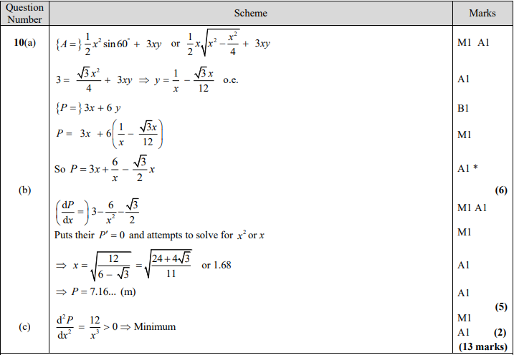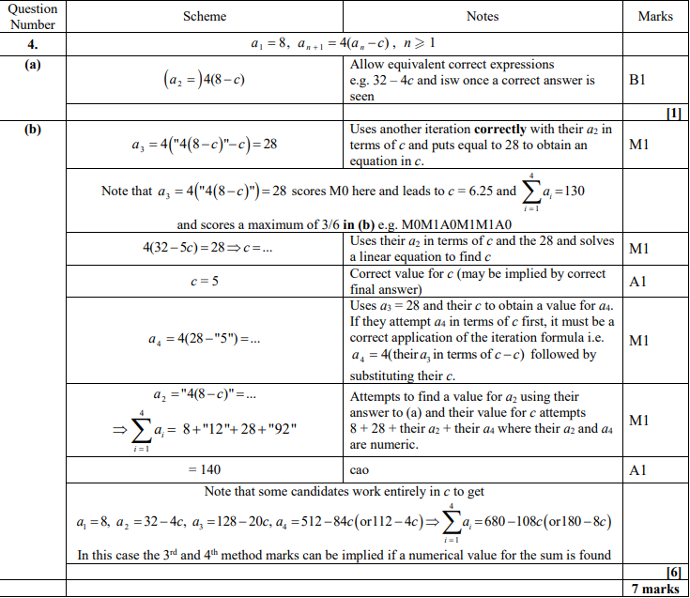

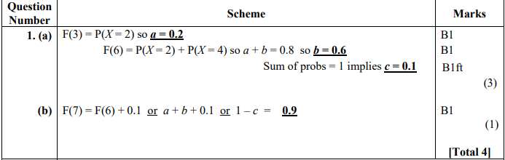

**27/12/19**

**Q16**

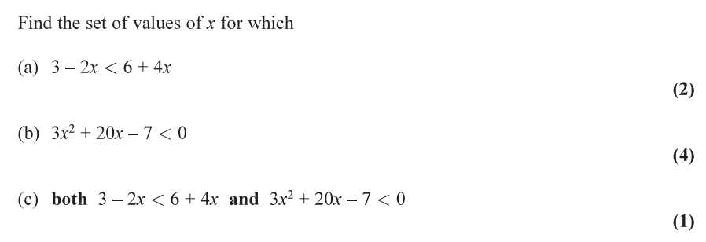

**…………………………………………………………………………………………………………**

**…………………………………………………………………………………………………………**

**…………………………………………………………………………………………………………**

**…………………………………………………………………………………………………………**

**…………………………………………………………………………………………………………**

**…………………………………………………………………………………………………………**

**…………………………………………………………………………………………………………**

**…………………………………………………………………………………………………………**

**…………………………………………………………………………………………………………**

**…………………………………………………………………………………………………………**

**…………………………………………………………………………………………………………**

**…………………………………………………………………………………………………………**

**…………………………………………………………………………………………………………**

**…………………………………………………………………………………………………………**

**…………………………………………………………………………………………………………**

**…………………………………………………………………………………………………………**

**…………………………………………………………………………………………………………**

**…………………………………………………………………………………………………………**

**…………………………………………………………………………………………………………**

**…………………………………………………………………………………………………………**

**…………………………………………………………………………………………………………**

**…………………………………………………………………………………………………………**

**…………………………………………………………………………………………………………**

**…………………………………………………………………………………………………………**

**…………………………………………………………………………………………………………**

**…………………………………………………………………………………………………………**

**…………………………………………………………………………………………………………**

**…………………………………………………………………………………………………………**

**…………………………………………………………………………………………………………**

**…………………………………………………………………………………………………………**

**…………………………………………………………………………………………………………**

**…………………………………………………………………………………………………………**

**…………………………………………………………………………………………………………**

**Q17**

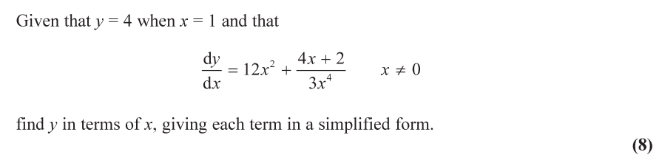

**…………………………………………………………………………………………………………**

**…………………………………………………………………………………………………………**

**…………………………………………………………………………………………………………**

**…………………………………………………………………………………………………………**

**…………………………………………………………………………………………………………**

**…………………………………………………………………………………………………………**

**…………………………………………………………………………………………………………**

**…………………………………………………………………………………………………………**

**…………………………………………………………………………………………………………**

**…………………………………………………………………………………………………………**

**…………………………………………………………………………………………………………**

**…………………………………………………………………………………………………………**

**…………………………………………………………………………………………………………**

**…………………………………………………………………………………………………………**

**…………………………………………………………………………………………………………**

**…………………………………………………………………………………………………………**

**…………………………………………………………………………………………………………**

**…………………………………………………………………………………………………………**

**…………………………………………………………………………………………………………**

**…………………………………………………………………………………………………………**

**…………………………………………………………………………………………………………**

**…………………………………………………………………………………………………………**

**…………………………………………………………………………………………………………**

**…………………………………………………………………………………………………………**

**…………………………………………………………………………………………………………**

**…………………………………………………………………………………………………………**

**…………………………………………………………………………………………………………**

**…………………………………………………………………………………………………………**

**…………………………………………………………………………………………………………**

**…………………………………………………………………………………………………………**

**…………………………………………………………………………………………………………**

**…………………………………………………………………………………………………………**

**…………………………………………………………………………………………………………**

**…………………………………………………………………………………………………………**

**…………………………………………………………………………………………………………**

**…………………………………………………………………………………………………………**

**Q18**

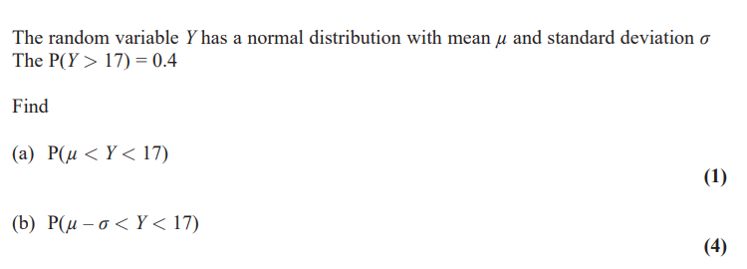

**…………………………………………………………………………………………………………**

**…………………………………………………………………………………………………………**

**…………………………………………………………………………………………………………**

**…………………………………………………………………………………………………………**

**…………………………………………………………………………………………………………**

**…………………………………………………………………………………………………………**

**…………………………………………………………………………………………………………**

**…………………………………………………………………………………………………………**

**…………………………………………………………………………………………………………**

**…………………………………………………………………………………………………………**

**…………………………………………………………………………………………………………**

**…………………………………………………………………………………………………………**

**…………………………………………………………………………………………………………**

**…………………………………………………………………………………………………………**

**…………………………………………………………………………………………………………**

**…………………………………………………………………………………………………………**

**…………………………………………………………………………………………………………**

**…………………………………………………………………………………………………………**

**…………………………………………………………………………………………………………**

**…………………………………………………………………………………………………………**

**…………………………………………………………………………………………………………**

**…………………………………………………………………………………………………………**

**…………………………………………………………………………………………………………**

**…………………………………………………………………………………………………………**

**…………………………………………………………………………………………………………**

**…………………………………………………………………………………………………………**

**…………………………………………………………………………………………………………**

**…………………………………………………………………………………………………………**

**…………………………………………………………………………………………………………**

**…………………………………………………………………………………………………………**

**…………………………………………………………………………………………………………**

**…………………………………………………………………………………………………………**

**…………………………………………………………………………………………………………**

**…………………………………………………………………………………………………………**

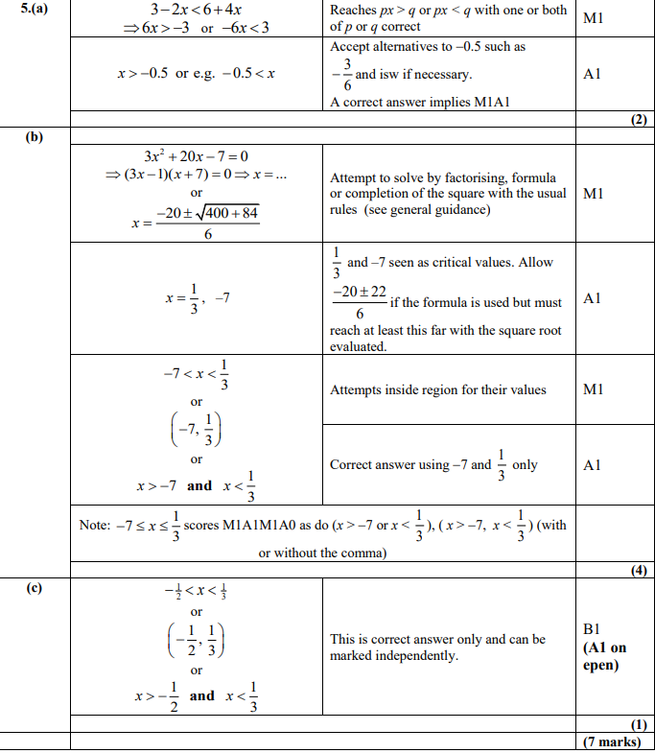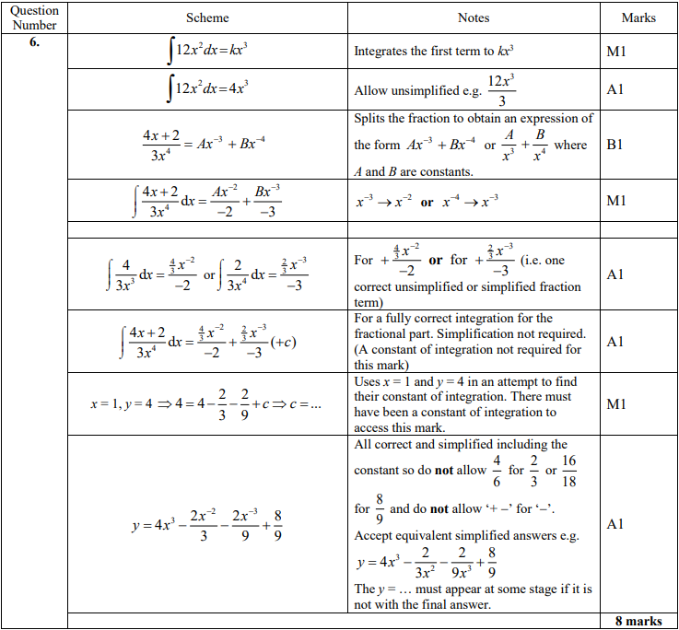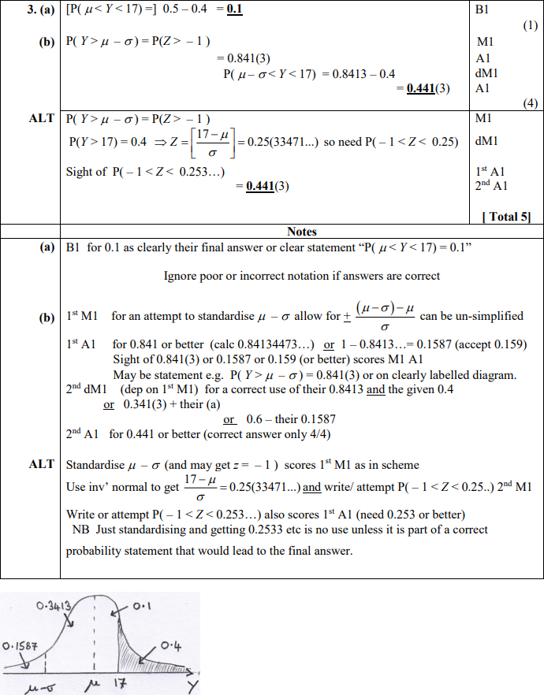

**28/12/19**

**Q19**

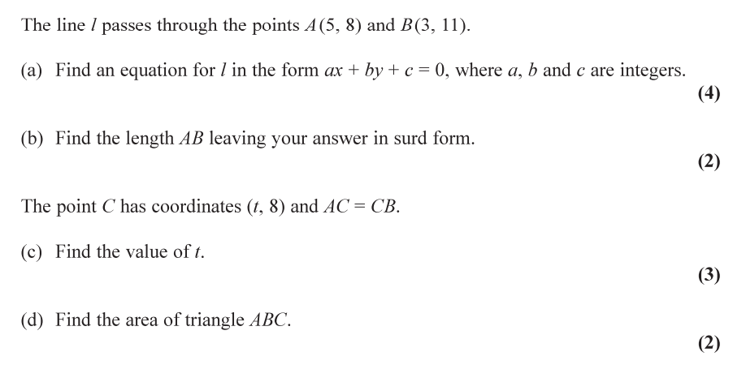

**…………………………………………………………………………………………………………**

**…………………………………………………………………………………………………………**

**…………………………………………………………………………………………………………**

**…………………………………………………………………………………………………………**

**…………………………………………………………………………………………………………**

**…………………………………………………………………………………………………………**

**…………………………………………………………………………………………………………**

**…………………………………………………………………………………………………………**

**…………………………………………………………………………………………………………**

**…………………………………………………………………………………………………………**

**…………………………………………………………………………………………………………**

**…………………………………………………………………………………………………………**

**…………………………………………………………………………………………………………**

**…………………………………………………………………………………………………………**

**…………………………………………………………………………………………………………**

**…………………………………………………………………………………………………………**

**…………………………………………………………………………………………………………**

**…………………………………………………………………………………………………………**

**…………………………………………………………………………………………………………**

**…………………………………………………………………………………………………………**

**…………………………………………………………………………………………………………**

**…………………………………………………………………………………………………………**

**…………………………………………………………………………………………………………**

**…………………………………………………………………………………………………………**

**…………………………………………………………………………………………………………**

**…………………………………………………………………………………………………………**

**…………………………………………………………………………………………………………**

**…………………………………………………………………………………………………………**

**…………………………………………………………………………………………………………**

**…………………………………………………………………………………………………………**

**…………………………………………………………………………………………………………**

**…………………………………………………………………………………………………………**

**Q20**

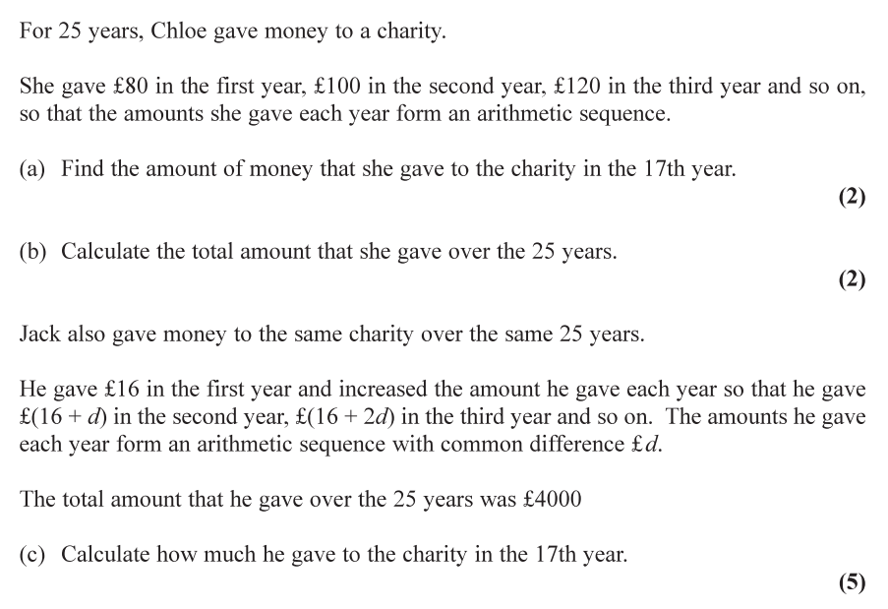

**…………………………………………………………………………………………………………**

**…………………………………………………………………………………………………………**

**…………………………………………………………………………………………………………**

**…………………………………………………………………………………………………………**

**…………………………………………………………………………………………………………**

**…………………………………………………………………………………………………………**

**…………………………………………………………………………………………………………**

**…………………………………………………………………………………………………………**

**…………………………………………………………………………………………………………**

**…………………………………………………………………………………………………………**

**…………………………………………………………………………………………………………**

**…………………………………………………………………………………………………………**

**…………………………………………………………………………………………………………**

**…………………………………………………………………………………………………………**

**…………………………………………………………………………………………………………**

**…………………………………………………………………………………………………………**

**…………………………………………………………………………………………………………**

**…………………………………………………………………………………………………………**

**…………………………………………………………………………………………………………**

**…………………………………………………………………………………………………………**

**…………………………………………………………………………………………………………**

**…………………………………………………………………………………………………………**

**…………………………………………………………………………………………………………**

**…………………………………………………………………………………………………………**

**…………………………………………………………………………………………………………**

**…………………………………………………………………………………………………………**

**…………………………………………………………………………………………………………**

**…………………………………………………………………………………………………………**

**…………………………………………………………………………………………………………**

**…………………………………………………………………………………………………………**

**Q21**

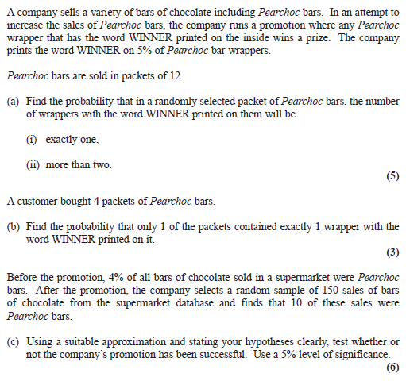

**…………………………………………………………………………………………………………**

**…………………………………………………………………………………………………………**

**…………………………………………………………………………………………………………**

**…………………………………………………………………………………………………………**

**…………………………………………………………………………………………………………**

**…………………………………………………………………………………………………………**

**…………………………………………………………………………………………………………**

**…………………………………………………………………………………………………………**

**…………………………………………………………………………………………………………**

**…………………………………………………………………………………………………………**

**…………………………………………………………………………………………………………**

**…………………………………………………………………………………………………………**

**…………………………………………………………………………………………………………**

**…………………………………………………………………………………………………………**

**…………………………………………………………………………………………………………**

**…………………………………………………………………………………………………………**

**…………………………………………………………………………………………………………**

**…………………………………………………………………………………………………………**

**…………………………………………………………………………………………………………**

**…………………………………………………………………………………………………………**

**…………………………………………………………………………………………………………**

**…………………………………………………………………………………………………………**

**…………………………………………………………………………………………………………**

**…………………………………………………………………………………………………………**

**…………………………………………………………………………………………………………**

**…………………………………………………………………………………………………………**

**…………………………………………………………………………………………………………**

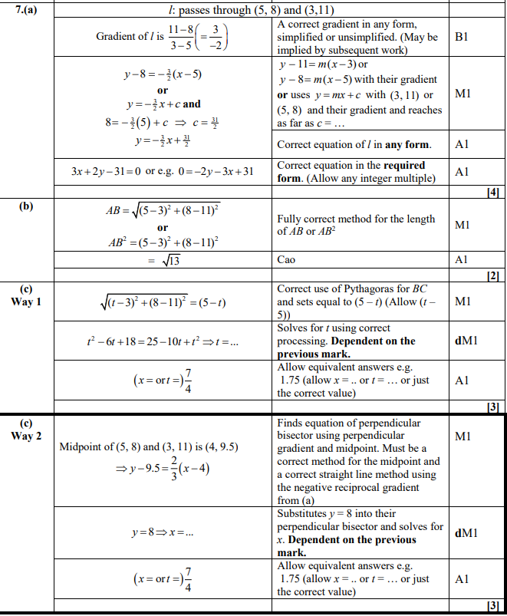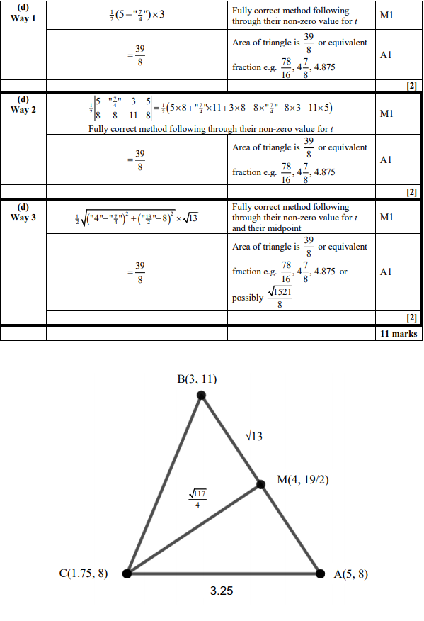

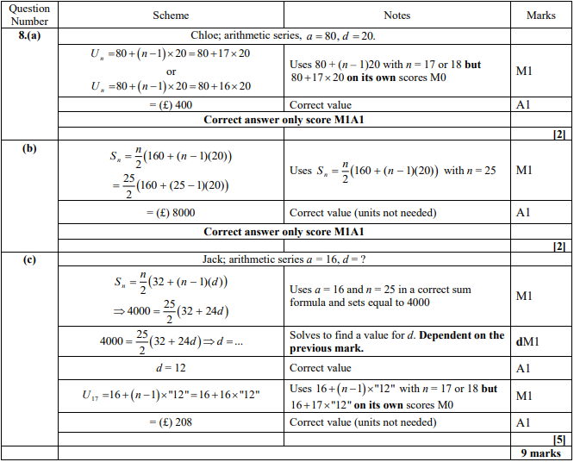

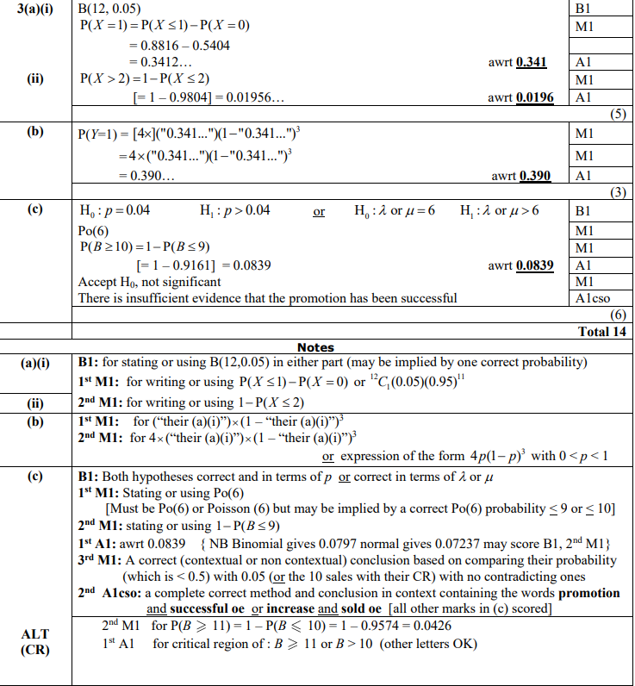

**29/12/19**

**Q22**

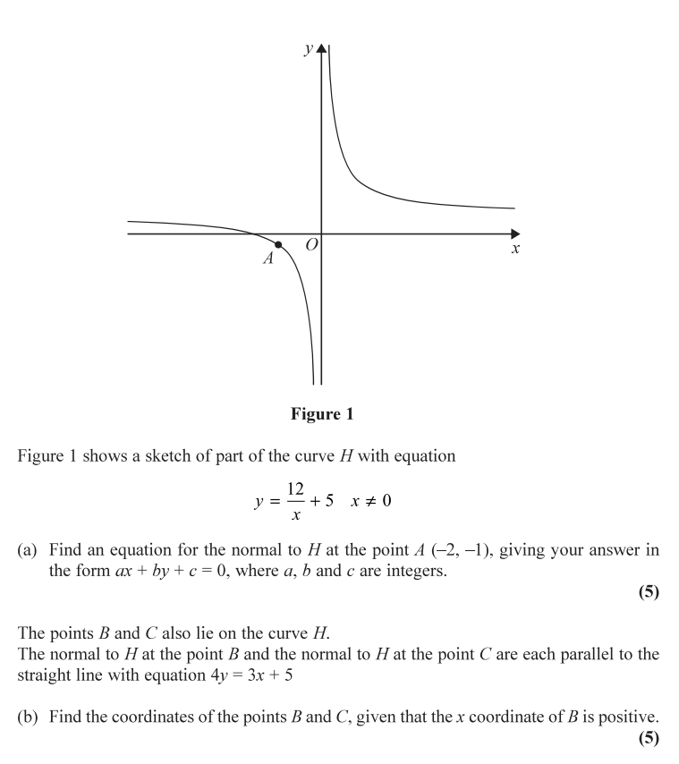

**…………………………………………………………………………………………………………**

**…………………………………………………………………………………………………………**

**…………………………………………………………………………………………………………**

**…………………………………………………………………………………………………………**

**…………………………………………………………………………………………………………**

**…………………………………………………………………………………………………………**

**…………………………………………………………………………………………………………**

**…………………………………………………………………………………………………………**

**…………………………………………………………………………………………………………**

**…………………………………………………………………………………………………………**

**…………………………………………………………………………………………………………**

**…………………………………………………………………………………………………………**

**…………………………………………………………………………………………………………**

**…………………………………………………………………………………………………………**

**…………………………………………………………………………………………………………**

**…………………………………………………………………………………………………………**

**…………………………………………………………………………………………………………**

**…………………………………………………………………………………………………………**

**…………………………………………………………………………………………………………**

**…………………………………………………………………………………………………………**

**…………………………………………………………………………………………………………**

**…………………………………………………………………………………………………………**

**Q23**

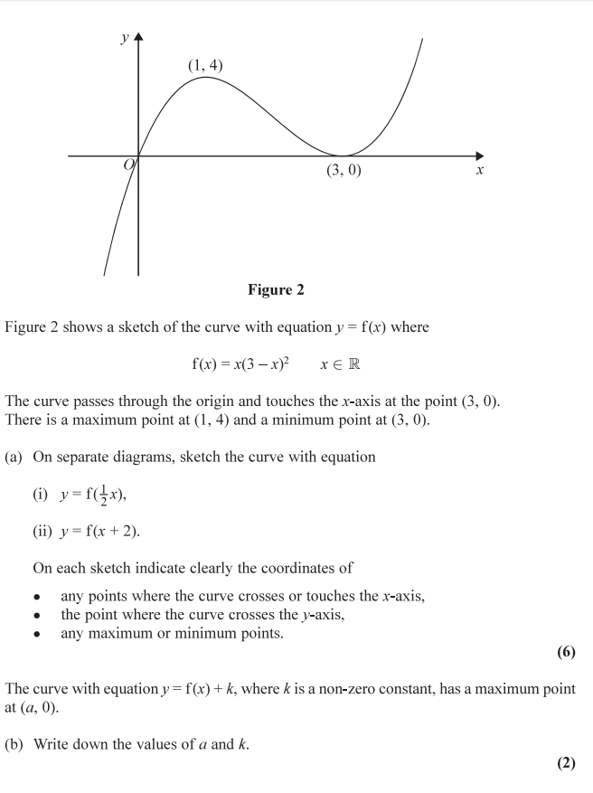

**…………………………………………………………………………………………………………**

**…………………………………………………………………………………………………………**

**…………………………………………………………………………………………………………**

**…………………………………………………………………………………………………………**

**…………………………………………………………………………………………………………**

**…………………………………………………………………………………………………………**

**…………………………………………………………………………………………………………**

**…………………………………………………………………………………………………………**

**…………………………………………………………………………………………………………**

**…………………………………………………………………………………………………………**

**…………………………………………………………………………………………………………**

**…………………………………………………………………………………………………………**

**…………………………………………………………………………………………………………**

**…………………………………………………………………………………………………………**

**…………………………………………………………………………………………………………**

**…………………………………………………………………………………………………………**

**…………………………………………………………………………………………………………**

**…………………………………………………………………………………………………………**

**…………………………………………………………………………………………………………**

**…………………………………………………………………………………………………………**

**…………………………………………………………………………………………………………**

**Q24**

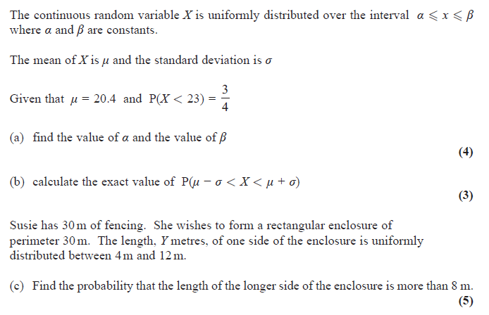

**…………………………………………………………………………………………………………**

**…………………………………………………………………………………………………………**

**…………………………………………………………………………………………………………**

**…………………………………………………………………………………………………………**

**…………………………………………………………………………………………………………**

**…………………………………………………………………………………………………………**

**…………………………………………………………………………………………………………**

**…………………………………………………………………………………………………………**

**…………………………………………………………………………………………………………**

**…………………………………………………………………………………………………………**

**…………………………………………………………………………………………………………**

**…………………………………………………………………………………………………………**

**…………………………………………………………………………………………………………**

**…………………………………………………………………………………………………………**

**…………………………………………………………………………………………………………**

**…………………………………………………………………………………………………………**

**…………………………………………………………………………………………………………**

**…………………………………………………………………………………………………………**

**…………………………………………………………………………………………………………**

**…………………………………………………………………………………………………………**

**…………………………………………………………………………………………………………**

**…………………………………………………………………………………………………………**

**…………………………………………………………………………………………………………**

**…………………………………………………………………………………………………………**

**…………………………………………………………………………………………………………**

**…………………………………………………………………………………………………………**

**…………………………………………………………………………………………………………**

**…………………………………………………………………………………………………………**

**…………………………………………………………………………………………………………**

**…………………………………………………………………………………………………………**

**…………………………………………………………………………………………………………**

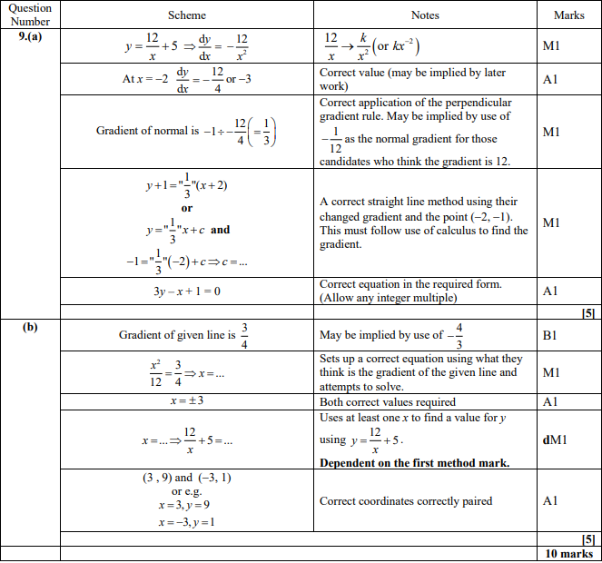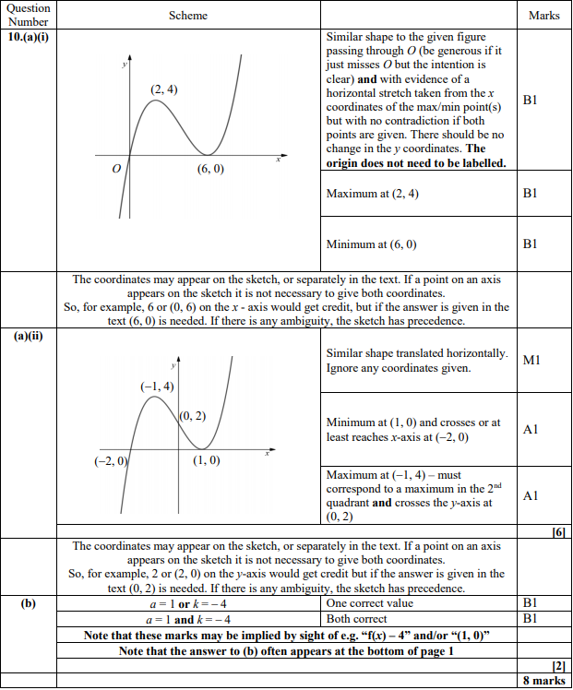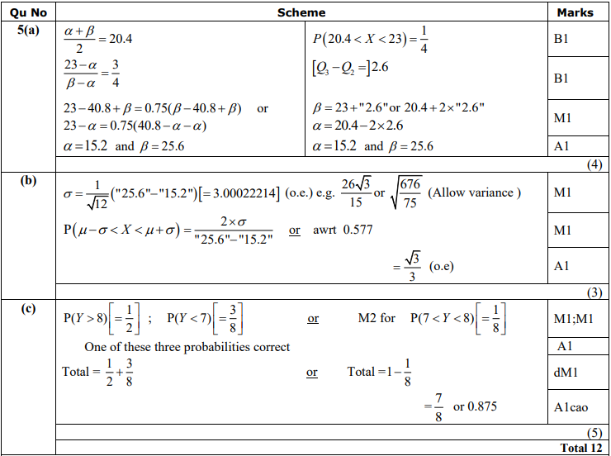

**30/12/19**

**Q25**

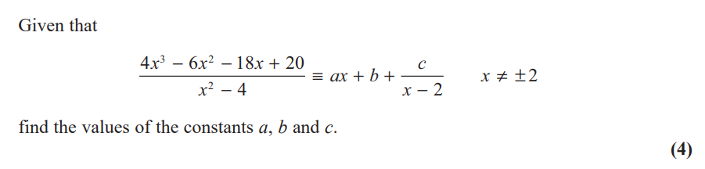

**…………………………………………………………………………………………………………**

**…………………………………………………………………………………………………………**

**…………………………………………………………………………………………………………**

**…………………………………………………………………………………………………………**

**…………………………………………………………………………………………………………**

**…………………………………………………………………………………………………………**

**…………………………………………………………………………………………………………**

**…………………………………………………………………………………………………………**

**…………………………………………………………………………………………………………**

**…………………………………………………………………………………………………………**

**…………………………………………………………………………………………………………**

**…………………………………………………………………………………………………………**

**…………………………………………………………………………………………………………**

**…………………………………………………………………………………………………………**

**…………………………………………………………………………………………………………**

**…………………………………………………………………………………………………………**

**…………………………………………………………………………………………………………**

**…………………………………………………………………………………………………………**

**…………………………………………………………………………………………………………**

**…………………………………………………………………………………………………………**

**…………………………………………………………………………………………………………**

**…………………………………………………………………………………………………………**

**…………………………………………………………………………………………………………**

**…………………………………………………………………………………………………………**

**…………………………………………………………………………………………………………**

**…………………………………………………………………………………………………………**

**…………………………………………………………………………………………………………**

**…………………………………………………………………………………………………………**

**…………………………………………………………………………………………………………**

**…………………………………………………………………………………………………………**

**…………………………………………………………………………………………………………**

**…………………………………………………………………………………………………………**

**…………………………………………………………………………………………………………**

**…………………………………………………………………………………………………………**

**…………………………………………………………………………………………………………**

**Q26**

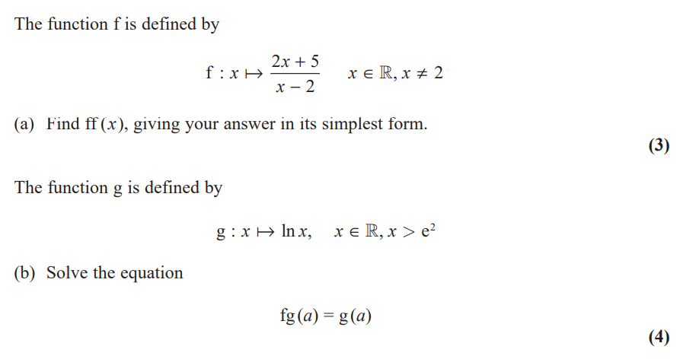

**…………………………………………………………………………………………………………**

**…………………………………………………………………………………………………………**

**…………………………………………………………………………………………………………**

**…………………………………………………………………………………………………………**

**…………………………………………………………………………………………………………**

**…………………………………………………………………………………………………………**

**…………………………………………………………………………………………………………**

**…………………………………………………………………………………………………………**

**…………………………………………………………………………………………………………**

**…………………………………………………………………………………………………………**

**…………………………………………………………………………………………………………**

**…………………………………………………………………………………………………………**

**…………………………………………………………………………………………………………**

**…………………………………………………………………………………………………………**

**…………………………………………………………………………………………………………**

**…………………………………………………………………………………………………………**

**…………………………………………………………………………………………………………**

**…………………………………………………………………………………………………………**

**…………………………………………………………………………………………………………**

**…………………………………………………………………………………………………………**

**…………………………………………………………………………………………………………**

**…………………………………………………………………………………………………………**

**…………………………………………………………………………………………………………**

**…………………………………………………………………………………………………………**

**…………………………………………………………………………………………………………**

**…………………………………………………………………………………………………………**

**…………………………………………………………………………………………………………**

**…………………………………………………………………………………………………………**

**…………………………………………………………………………………………………………**

**…………………………………………………………………………………………………………**

**…………………………………………………………………………………………………………**

**…………………………………………………………………………………………………………**

**Q27**

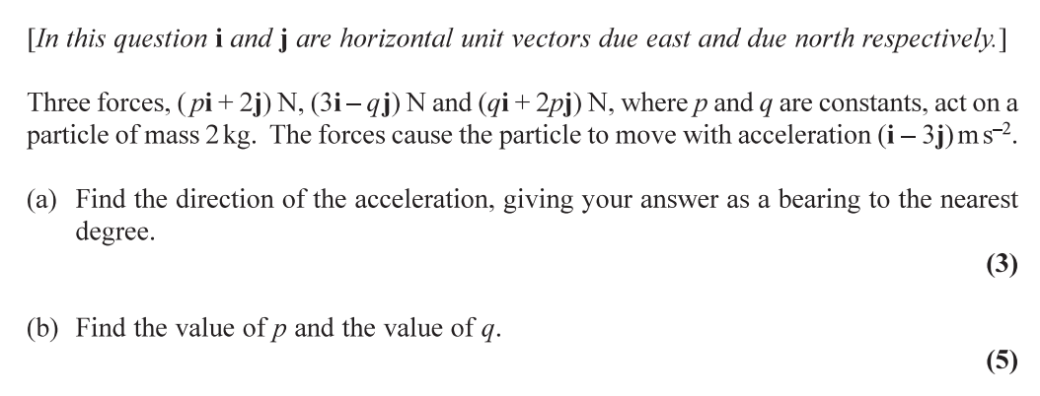

**…………………………………………………………………………………………………………**

**…………………………………………………………………………………………………………**

**…………………………………………………………………………………………………………**

**…………………………………………………………………………………………………………**

**…………………………………………………………………………………………………………**

**…………………………………………………………………………………………………………**

**…………………………………………………………………………………………………………**

**…………………………………………………………………………………………………………**

**…………………………………………………………………………………………………………**

**…………………………………………………………………………………………………………**

**…………………………………………………………………………………………………………**

**…………………………………………………………………………………………………………**

**…………………………………………………………………………………………………………**

**…………………………………………………………………………………………………………**

**…………………………………………………………………………………………………………**

**…………………………………………………………………………………………………………**

**…………………………………………………………………………………………………………**

**…………………………………………………………………………………………………………**

**…………………………………………………………………………………………………………**

**…………………………………………………………………………………………………………**

**…………………………………………………………………………………………………………**

**…………………………………………………………………………………………………………**

**…………………………………………………………………………………………………………**

**…………………………………………………………………………………………………………**

**…………………………………………………………………………………………………………**

**…………………………………………………………………………………………………………**

**…………………………………………………………………………………………………………**

**…………………………………………………………………………………………………………**

**…………………………………………………………………………………………………………**

**…………………………………………………………………………………………………………**

**…………………………………………………………………………………………………………**

**…………………………………………………………………………………………………………**

**…………………………………………………………………………………………………………**

**…………………………………………………………………………………………………………**

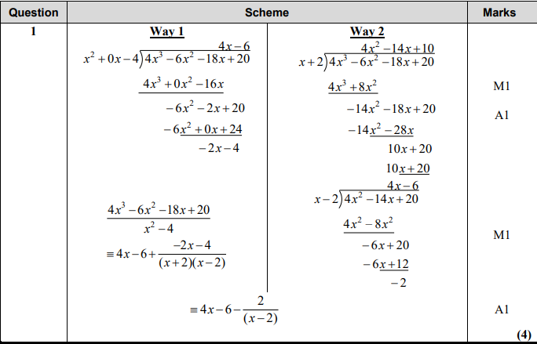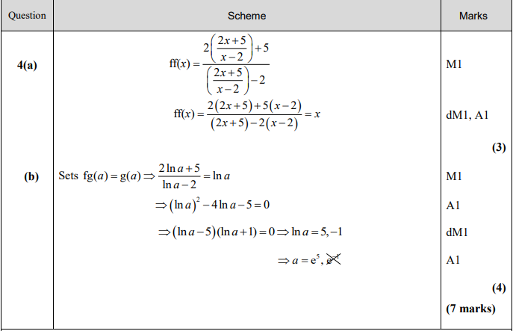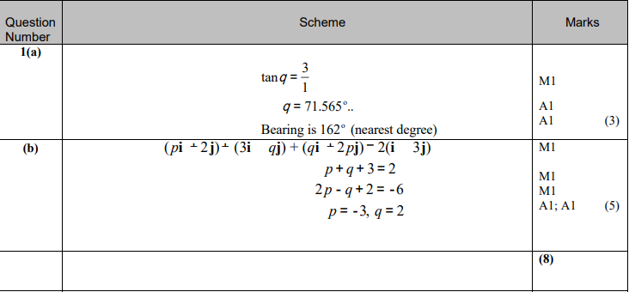

**31/12/19**

**Q28**

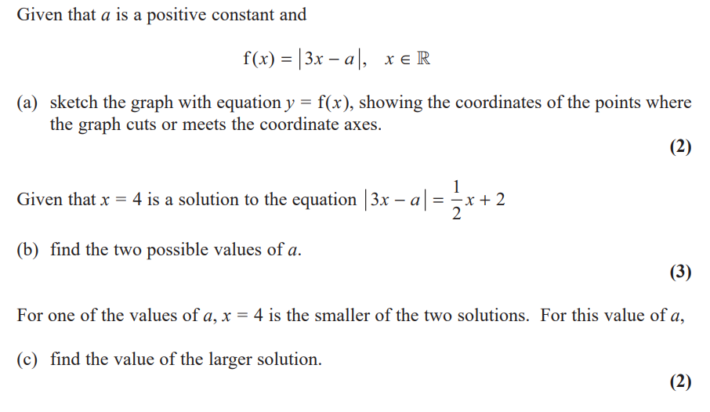

**…………………………………………………………………………………………………………**

**…………………………………………………………………………………………………………**

**…………………………………………………………………………………………………………**

**…………………………………………………………………………………………………………**

**…………………………………………………………………………………………………………**

**…………………………………………………………………………………………………………**

**…………………………………………………………………………………………………………**

**…………………………………………………………………………………………………………**

**…………………………………………………………………………………………………………**

**…………………………………………………………………………………………………………**

**…………………………………………………………………………………………………………**

**…………………………………………………………………………………………………………**

**…………………………………………………………………………………………………………**

**…………………………………………………………………………………………………………**

**…………………………………………………………………………………………………………**

**…………………………………………………………………………………………………………**

**…………………………………………………………………………………………………………**

**…………………………………………………………………………………………………………**

**…………………………………………………………………………………………………………**

**…………………………………………………………………………………………………………**

**…………………………………………………………………………………………………………**

**…………………………………………………………………………………………………………**

**…………………………………………………………………………………………………………**

**…………………………………………………………………………………………………………**

**…………………………………………………………………………………………………………**

**…………………………………………………………………………………………………………**

**…………………………………………………………………………………………………………**

**…………………………………………………………………………………………………………**

**…………………………………………………………………………………………………………**

**…………………………………………………………………………………………………………**

**…………………………………………………………………………………………………………**

**Q29**

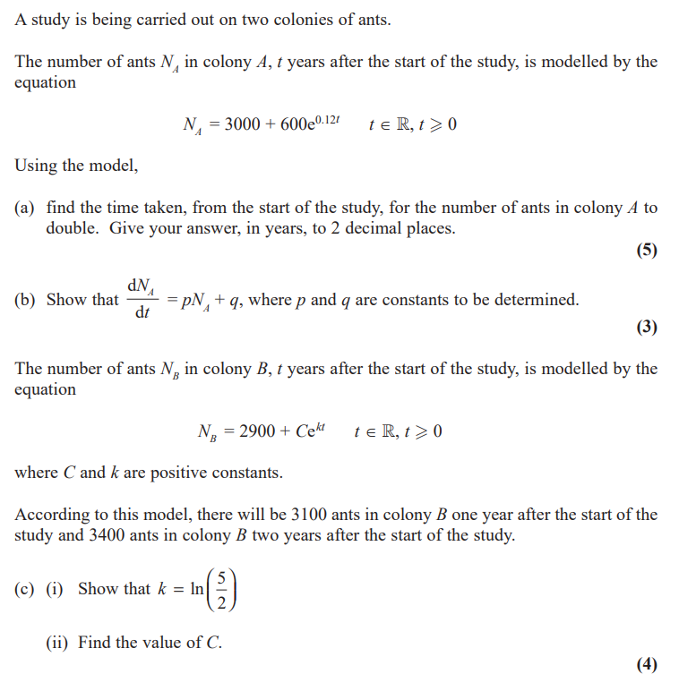

**…………………………………………………………………………………………………………**

**…………………………………………………………………………………………………………**

**…………………………………………………………………………………………………………**

**…………………………………………………………………………………………………………**

**…………………………………………………………………………………………………………**

**…………………………………………………………………………………………………………**

**…………………………………………………………………………………………………………**

**…………………………………………………………………………………………………………**

**…………………………………………………………………………………………………………**

**…………………………………………………………………………………………………………**

**…………………………………………………………………………………………………………**

**…………………………………………………………………………………………………………**

**…………………………………………………………………………………………………………**

**…………………………………………………………………………………………………………**

**…………………………………………………………………………………………………………**

**…………………………………………………………………………………………………………**

**…………………………………………………………………………………………………………**

**…………………………………………………………………………………………………………**

**…………………………………………………………………………………………………………**

**…………………………………………………………………………………………………………**

**…………………………………………………………………………………………………………**

**…………………………………………………………………………………………………………**

**…………………………………………………………………………………………………………**

**…………………………………………………………………………………………………………**

**…………………………………………………………………………………………………………**

**…………………………………………………………………………………………………………**

**Q30**

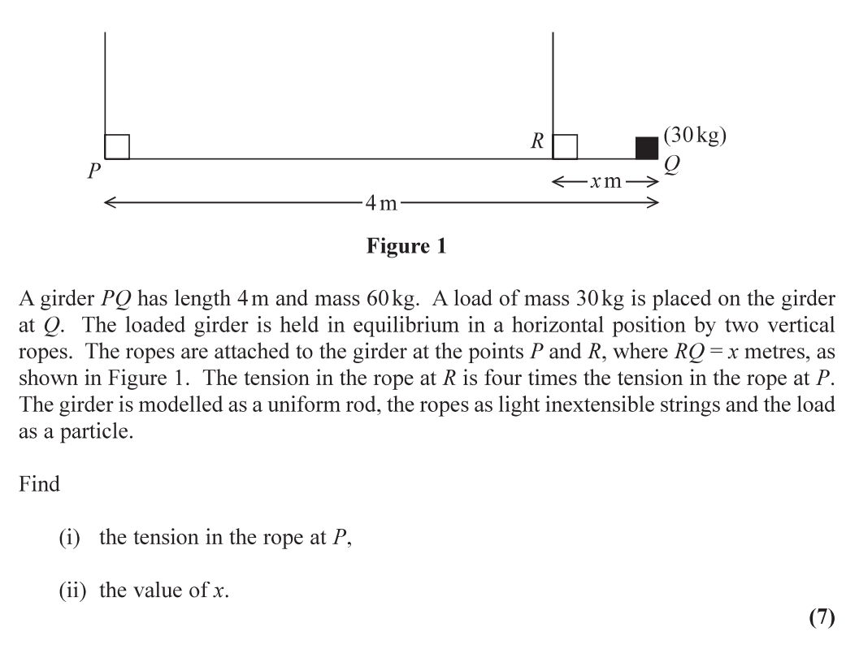

**…………………………………………………………………………………………………………**

**…………………………………………………………………………………………………………**

**…………………………………………………………………………………………………………**

**…………………………………………………………………………………………………………**

**…………………………………………………………………………………………………………**

**…………………………………………………………………………………………………………**

**…………………………………………………………………………………………………………**

**…………………………………………………………………………………………………………**

**…………………………………………………………………………………………………………**

**…………………………………………………………………………………………………………**

**…………………………………………………………………………………………………………**

**…………………………………………………………………………………………………………**

**…………………………………………………………………………………………………………**

**…………………………………………………………………………………………………………**

**…………………………………………………………………………………………………………**

**…………………………………………………………………………………………………………**

**…………………………………………………………………………………………………………**

**…………………………………………………………………………………………………………**

**…………………………………………………………………………………………………………**

**…………………………………………………………………………………………………………**

**…………………………………………………………………………………………………………**

**…………………………………………………………………………………………………………**

**…………………………………………………………………………………………………………**

**…………………………………………………………………………………………………………**

**…………………………………………………………………………………………………………**

**…………………………………………………………………………………………………………**

**…………………………………………………………………………………………………………**

**…………………………………………………………………………………………………………**

**…………………………………………………………………………………………………………**

**…………………………………………………………………………………………………………**

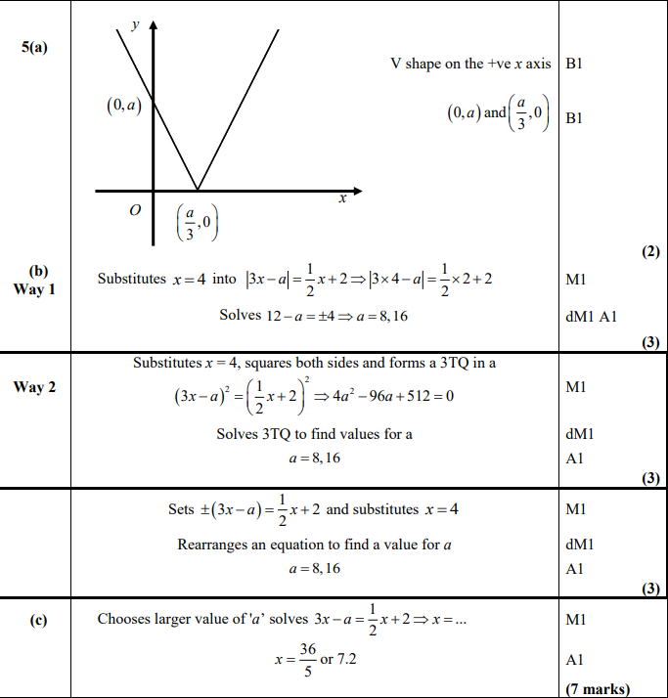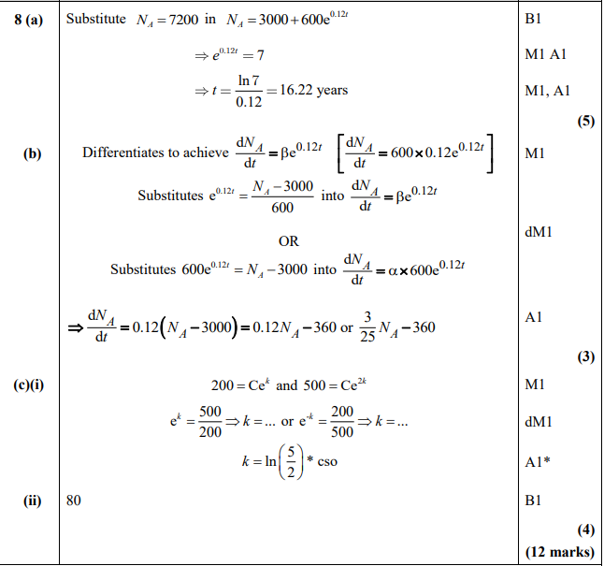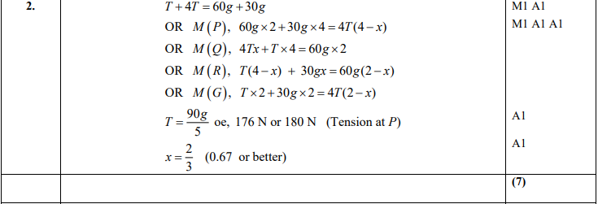

**01/01/20**

**Q31**

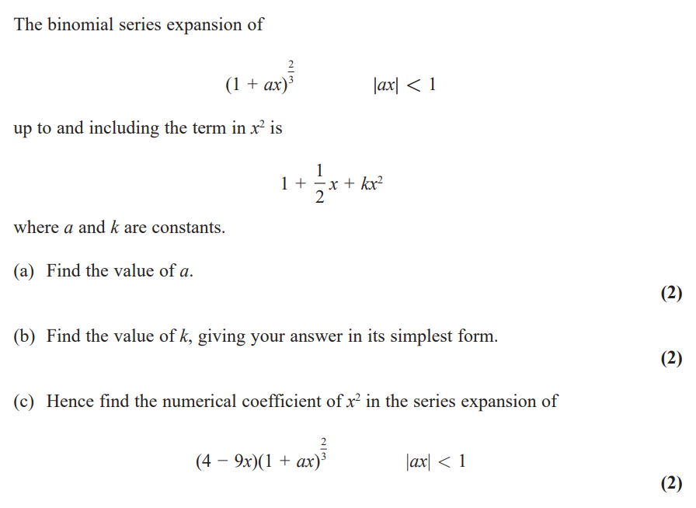

**…………………………………………………………………………………………………………**

**…………………………………………………………………………………………………………**

**…………………………………………………………………………………………………………**

**…………………………………………………………………………………………………………**

**…………………………………………………………………………………………………………**

**…………………………………………………………………………………………………………**

**…………………………………………………………………………………………………………**

**…………………………………………………………………………………………………………**

**…………………………………………………………………………………………………………**

**…………………………………………………………………………………………………………**

**…………………………………………………………………………………………………………**

**…………………………………………………………………………………………………………**

**…………………………………………………………………………………………………………**

**…………………………………………………………………………………………………………**

**…………………………………………………………………………………………………………**

**…………………………………………………………………………………………………………**

**…………………………………………………………………………………………………………**

**…………………………………………………………………………………………………………**

**…………………………………………………………………………………………………………**

**…………………………………………………………………………………………………………**

**…………………………………………………………………………………………………………**

**…………………………………………………………………………………………………………**

**…………………………………………………………………………………………………………**

**…………………………………………………………………………………………………………**

**…………………………………………………………………………………………………………**

**…………………………………………………………………………………………………………**

**…………………………………………………………………………………………………………**

**…………………………………………………………………………………………………………**

**…………………………………………………………………………………………………………**

**Q32**

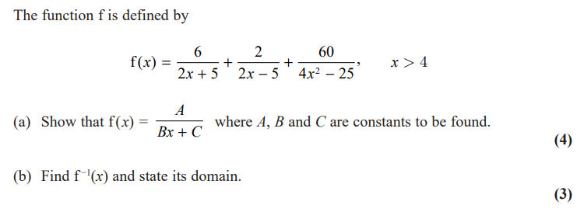

**…………………………………………………………………………………………………………**

**…………………………………………………………………………………………………………**

**…………………………………………………………………………………………………………**

**…………………………………………………………………………………………………………**

**…………………………………………………………………………………………………………**

**…………………………………………………………………………………………………………**

**…………………………………………………………………………………………………………**

**…………………………………………………………………………………………………………**

**…………………………………………………………………………………………………………**

**…………………………………………………………………………………………………………**

**…………………………………………………………………………………………………………**

**…………………………………………………………………………………………………………**

**…………………………………………………………………………………………………………**

**…………………………………………………………………………………………………………**

**…………………………………………………………………………………………………………**

**…………………………………………………………………………………………………………**

**…………………………………………………………………………………………………………**

**…………………………………………………………………………………………………………**

**…………………………………………………………………………………………………………**

**…………………………………………………………………………………………………………**

**…………………………………………………………………………………………………………**

**…………………………………………………………………………………………………………**

**…………………………………………………………………………………………………………**

**…………………………………………………………………………………………………………**

**…………………………………………………………………………………………………………**

**…………………………………………………………………………………………………………**

**…………………………………………………………………………………………………………**

**…………………………………………………………………………………………………………**

**…………………………………………………………………………………………………………**

**…………………………………………………………………………………………………………**

**…………………………………………………………………………………………………………**

**…………………………………………………………………………………………………………**

**…………………………………………………………………………………………………………**

**…………………………………………………………………………………………………………**

**Q33**

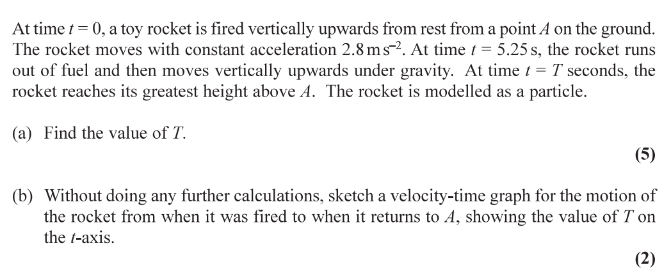

**…………………………………………………………………………………………………………**

**…………………………………………………………………………………………………………**

**…………………………………………………………………………………………………………**

**…………………………………………………………………………………………………………**

**…………………………………………………………………………………………………………**

**…………………………………………………………………………………………………………**

**…………………………………………………………………………………………………………**

**…………………………………………………………………………………………………………**

**…………………………………………………………………………………………………………**

**…………………………………………………………………………………………………………**

**…………………………………………………………………………………………………………**

**…………………………………………………………………………………………………………**

**…………………………………………………………………………………………………………**

**…………………………………………………………………………………………………………**

**…………………………………………………………………………………………………………**

**…………………………………………………………………………………………………………**

**…………………………………………………………………………………………………………**

**…………………………………………………………………………………………………………**

**…………………………………………………………………………………………………………**

**…………………………………………………………………………………………………………**

**…………………………………………………………………………………………………………**

**…………………………………………………………………………………………………………**

**…………………………………………………………………………………………………………**

**…………………………………………………………………………………………………………**

**…………………………………………………………………………………………………………**

**…………………………………………………………………………………………………………**

**…………………………………………………………………………………………………………**

**…………………………………………………………………………………………………………**

**…………………………………………………………………………………………………………**

**…………………………………………………………………………………………………………**

**…………………………………………………………………………………………………………**

**…………………………………………………………………………………………………………**

**…………………………………………………………………………………………………………**

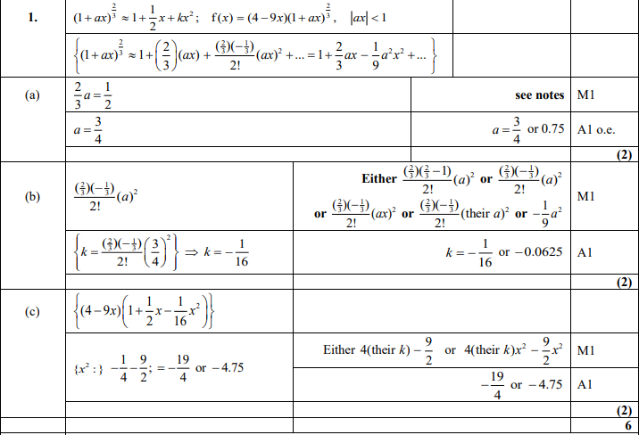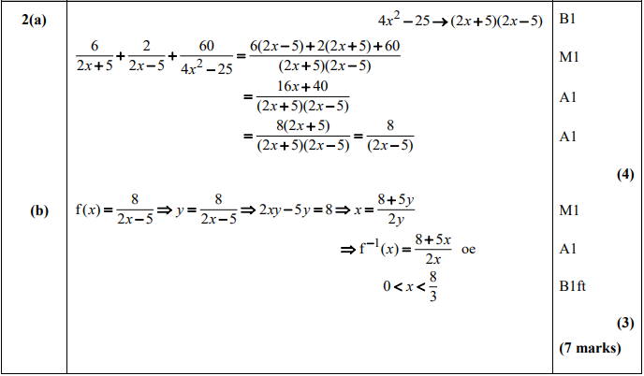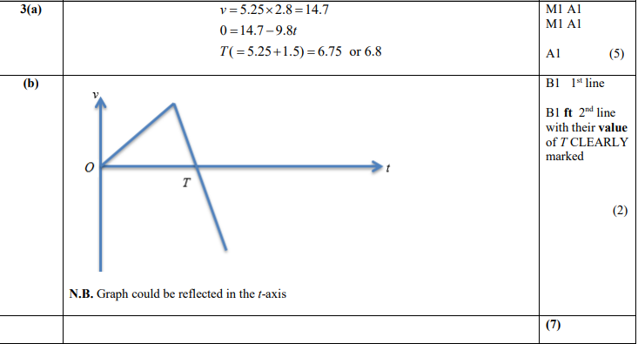

**02/01/20**

**Q34**

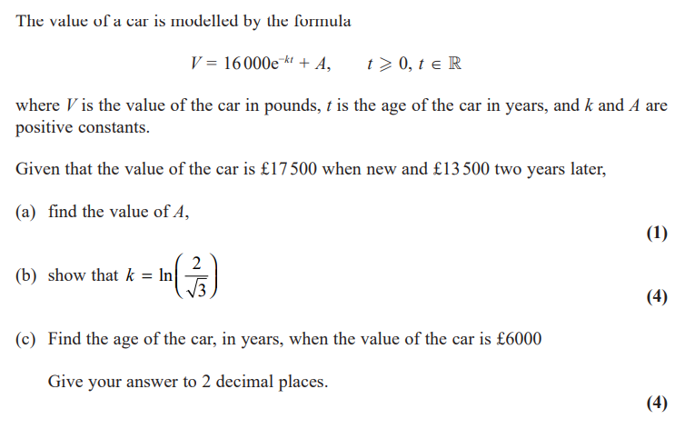

**…………………………………………………………………………………………………………**

**…………………………………………………………………………………………………………**

**…………………………………………………………………………………………………………**

**…………………………………………………………………………………………………………**

**…………………………………………………………………………………………………………**

**…………………………………………………………………………………………………………**

**…………………………………………………………………………………………………………**

**…………………………………………………………………………………………………………**

**…………………………………………………………………………………………………………**

**…………………………………………………………………………………………………………**

**…………………………………………………………………………………………………………**

**…………………………………………………………………………………………………………**

**…………………………………………………………………………………………………………**

**…………………………………………………………………………………………………………**

**…………………………………………………………………………………………………………**

**…………………………………………………………………………………………………………**

**…………………………………………………………………………………………………………**

**…………………………………………………………………………………………………………**

**…………………………………………………………………………………………………………**

**…………………………………………………………………………………………………………**

**…………………………………………………………………………………………………………**

**…………………………………………………………………………………………………………**

**…………………………………………………………………………………………………………**

**…………………………………………………………………………………………………………**

**…………………………………………………………………………………………………………**

**…………………………………………………………………………………………………………**

**…………………………………………………………………………………………………………**

**…………………………………………………………………………………………………………**

**…………………………………………………………………………………………………………**

**…………………………………………………………………………………………………………**

**…………………………………………………………………………………………………………**

**Q35**

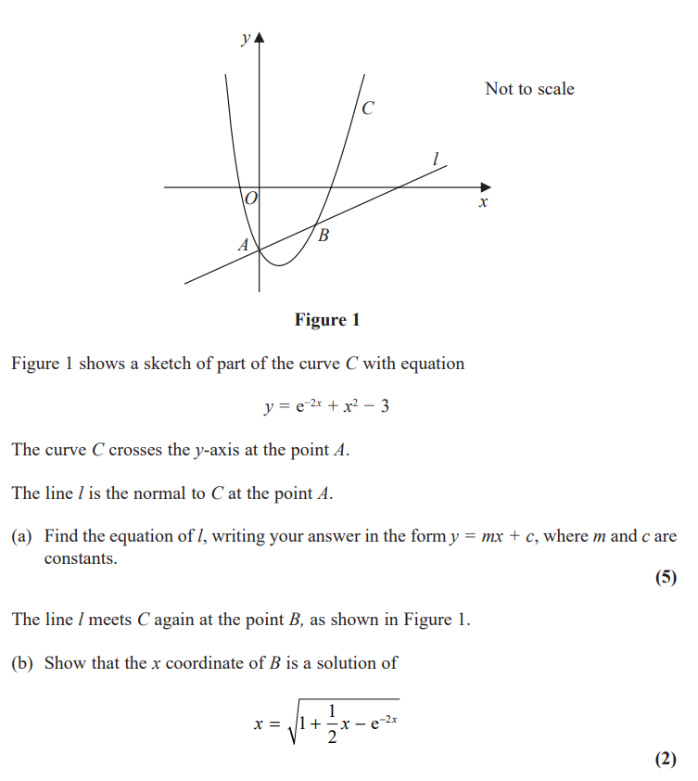

**…………………………………………………………………………………………………………**

**…………………………………………………………………………………………………………**

**…………………………………………………………………………………………………………**

**…………………………………………………………………………………………………………**

**…………………………………………………………………………………………………………**

**…………………………………………………………………………………………………………**

**…………………………………………………………………………………………………………**

**…………………………………………………………………………………………………………**

**…………………………………………………………………………………………………………**

**…………………………………………………………………………………………………………**

**…………………………………………………………………………………………………………**

**…………………………………………………………………………………………………………**

**…………………………………………………………………………………………………………**

**…………………………………………………………………………………………………………**

**…………………………………………………………………………………………………………**

**…………………………………………………………………………………………………………**

**…………………………………………………………………………………………………………**

**…………………………………………………………………………………………………………**

**…………………………………………………………………………………………………………**

**…………………………………………………………………………………………………………**

**…………………………………………………………………………………………………………**

**…………………………………………………………………………………………………………**

**…………………………………………………………………………………………………………**

**…………………………………………………………………………………………………………**

**…………………………………………………………………………………………………………**

**Q36**

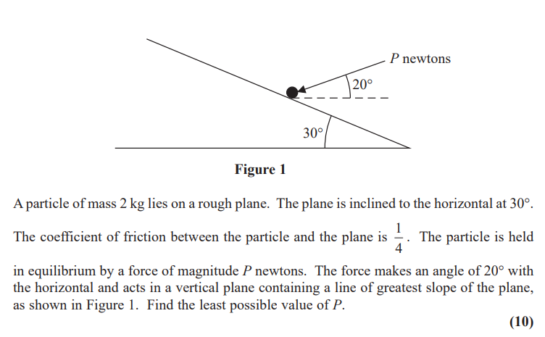

**…………………………………………………………………………………………………………**

**…………………………………………………………………………………………………………**

**…………………………………………………………………………………………………………**

**…………………………………………………………………………………………………………**

**…………………………………………………………………………………………………………**

**…………………………………………………………………………………………………………**

**…………………………………………………………………………………………………………**

**…………………………………………………………………………………………………………**

**…………………………………………………………………………………………………………**

**…………………………………………………………………………………………………………**

**…………………………………………………………………………………………………………**

**…………………………………………………………………………………………………………**

**…………………………………………………………………………………………………………**

**…………………………………………………………………………………………………………**

**…………………………………………………………………………………………………………**

**…………………………………………………………………………………………………………**

**…………………………………………………………………………………………………………**

**…………………………………………………………………………………………………………**

**…………………………………………………………………………………………………………**

**…………………………………………………………………………………………………………**

**…………………………………………………………………………………………………………**

**…………………………………………………………………………………………………………**

**…………………………………………………………………………………………………………**

**…………………………………………………………………………………………………………**

**…………………………………………………………………………………………………………**

**…………………………………………………………………………………………………………**

**…………………………………………………………………………………………………………**

**…………………………………………………………………………………………………………**

**…………………………………………………………………………………………………………**

**…………………………………………………………………………………………………………**

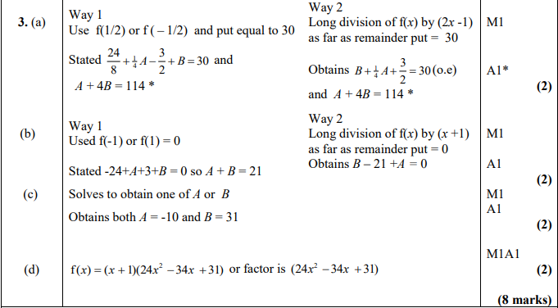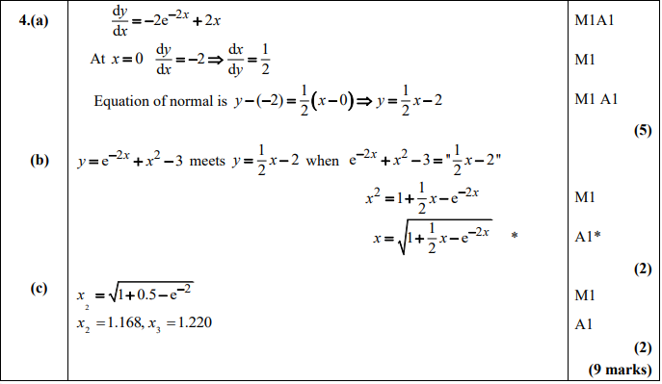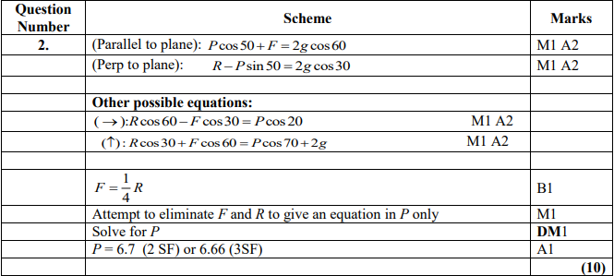

**03/01/20**

**Q37**

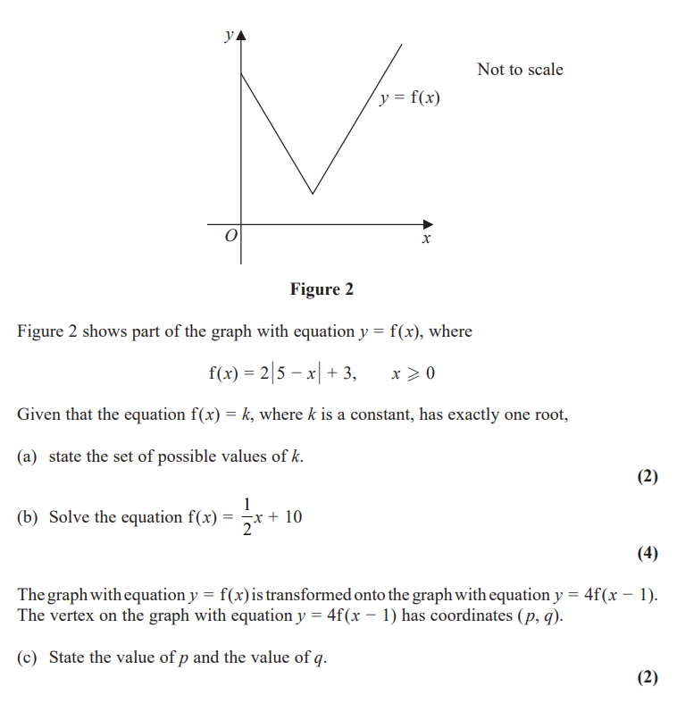

**…………………………………………………………………………………………………………**

**…………………………………………………………………………………………………………**

**…………………………………………………………………………………………………………**

**…………………………………………………………………………………………………………**

**…………………………………………………………………………………………………………**

**…………………………………………………………………………………………………………**

**…………………………………………………………………………………………………………**

**…………………………………………………………………………………………………………**

**…………………………………………………………………………………………………………**

**…………………………………………………………………………………………………………**

**…………………………………………………………………………………………………………**

**…………………………………………………………………………………………………………**

**…………………………………………………………………………………………………………**

**…………………………………………………………………………………………………………**

**…………………………………………………………………………………………………………**

**…………………………………………………………………………………………………………**

**…………………………………………………………………………………………………………**

**…………………………………………………………………………………………………………**

**…………………………………………………………………………………………………………**

**…………………………………………………………………………………………………………**

**…………………………………………………………………………………………………………**

**…………………………………………………………………………………………………………**

**…………………………………………………………………………………………………………**

**…………………………………………………………………………………………………………**

**…………………………………………………………………………………………………………**

**Q38**

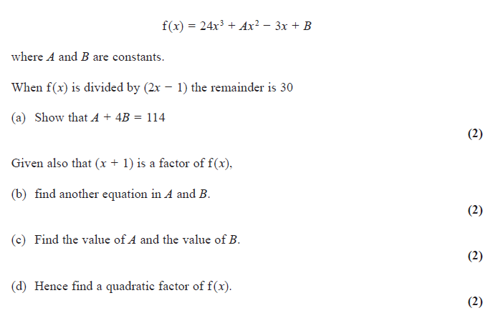

**…………………………………………………………………………………………………………**

**…………………………………………………………………………………………………………**

**…………………………………………………………………………………………………………**

**…………………………………………………………………………………………………………**

**…………………………………………………………………………………………………………**

**…………………………………………………………………………………………………………**

**…………………………………………………………………………………………………………**

**…………………………………………………………………………………………………………**

**…………………………………………………………………………………………………………**

**…………………………………………………………………………………………………………**

**…………………………………………………………………………………………………………**

**…………………………………………………………………………………………………………**

**…………………………………………………………………………………………………………**

**…………………………………………………………………………………………………………**

**…………………………………………………………………………………………………………**

**…………………………………………………………………………………………………………**

**…………………………………………………………………………………………………………**

**…………………………………………………………………………………………………………**

**…………………………………………………………………………………………………………**

**…………………………………………………………………………………………………………**

**…………………………………………………………………………………………………………**

**…………………………………………………………………………………………………………**

**…………………………………………………………………………………………………………**

**…………………………………………………………………………………………………………**

**…………………………………………………………………………………………………………**

**…………………………………………………………………………………………………………**

**…………………………………………………………………………………………………………**

**…………………………………………………………………………………………………………**

**…………………………………………………………………………………………………………**

**…………………………………………………………………………………………………………**

**Q39**

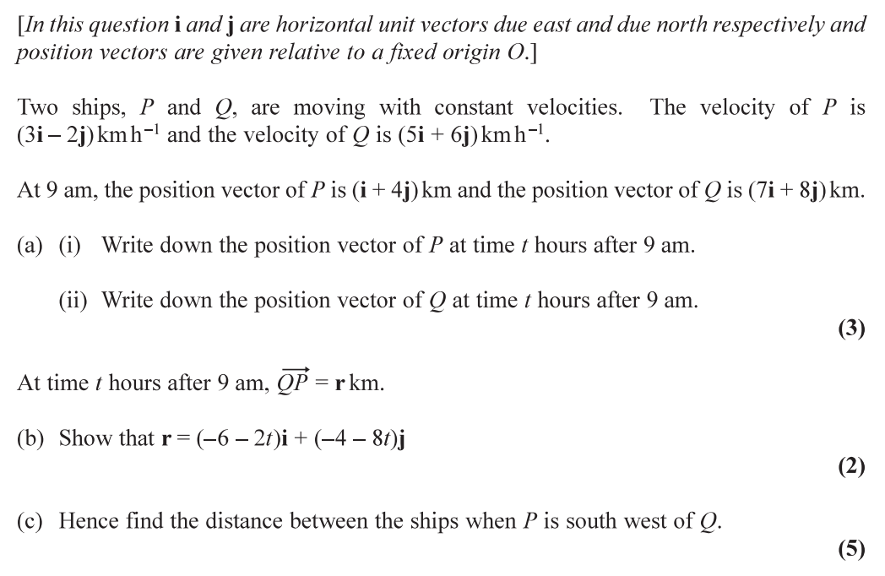

**…………………………………………………………………………………………………………**

**…………………………………………………………………………………………………………**

**…………………………………………………………………………………………………………**

**…………………………………………………………………………………………………………**

**…………………………………………………………………………………………………………**

**…………………………………………………………………………………………………………**

**…………………………………………………………………………………………………………**

**…………………………………………………………………………………………………………**

**…………………………………………………………………………………………………………**

**…………………………………………………………………………………………………………**

**…………………………………………………………………………………………………………**

**…………………………………………………………………………………………………………**

**…………………………………………………………………………………………………………**

**…………………………………………………………………………………………………………**

**…………………………………………………………………………………………………………**

**…………………………………………………………………………………………………………**

**…………………………………………………………………………………………………………**

**…………………………………………………………………………………………………………**

**…………………………………………………………………………………………………………**

**…………………………………………………………………………………………………………**

**…………………………………………………………………………………………………………**

**…………………………………………………………………………………………………………**

**…………………………………………………………………………………………………………**

**…………………………………………………………………………………………………………**

**…………………………………………………………………………………………………………**

**…………………………………………………………………………………………………………**

**…………………………………………………………………………………………………………**

**…………………………………………………………………………………………………………**

**…………………………………………………………………………………………………………**

**…………………………………………………………………………………………………………**

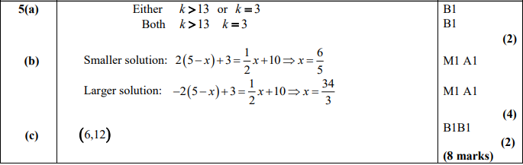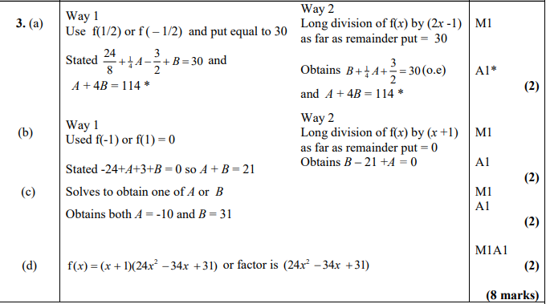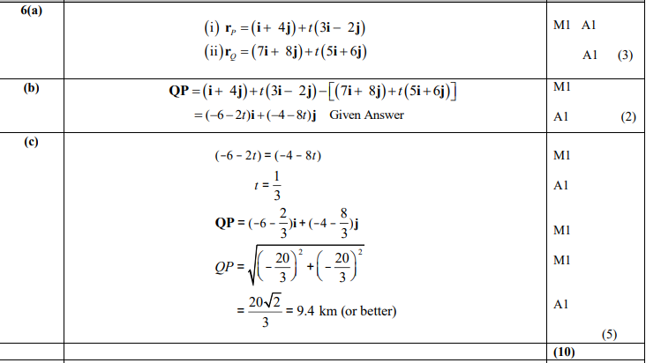

**04/01/20**

**Q40**

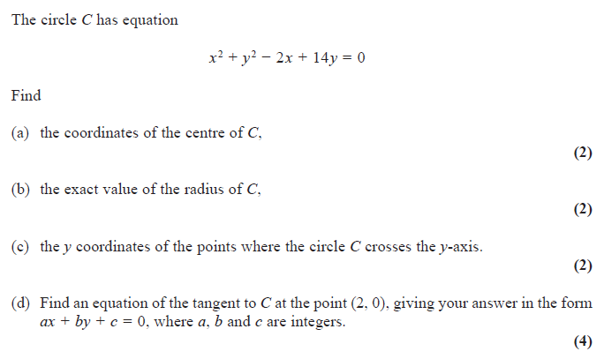

**…………………………………………………………………………………………………………**

**…………………………………………………………………………………………………………**

**…………………………………………………………………………………………………………**

**…………………………………………………………………………………………………………**

**…………………………………………………………………………………………………………**

**…………………………………………………………………………………………………………**

**…………………………………………………………………………………………………………**

**…………………………………………………………………………………………………………**

**…………………………………………………………………………………………………………**

**…………………………………………………………………………………………………………**

**…………………………………………………………………………………………………………**

**…………………………………………………………………………………………………………**

**…………………………………………………………………………………………………………**

**…………………………………………………………………………………………………………**

**…………………………………………………………………………………………………………**

**…………………………………………………………………………………………………………**

**…………………………………………………………………………………………………………**

**…………………………………………………………………………………………………………**

**…………………………………………………………………………………………………………**

**…………………………………………………………………………………………………………**

**…………………………………………………………………………………………………………**

**…………………………………………………………………………………………………………**

**…………………………………………………………………………………………………………**

**…………………………………………………………………………………………………………**

**…………………………………………………………………………………………………………**

**…………………………………………………………………………………………………………**

**…………………………………………………………………………………………………………**

**…………………………………………………………………………………………………………**

**…………………………………………………………………………………………………………**

**…………………………………………………………………………………………………………**

**Q41**

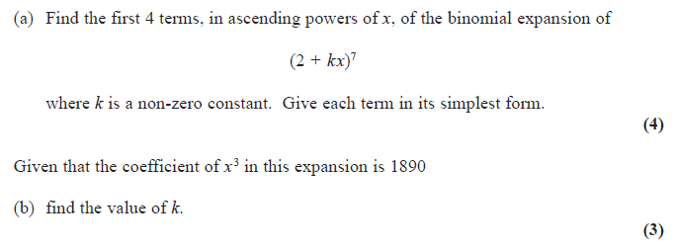

**…………………………………………………………………………………………………………**

**…………………………………………………………………………………………………………**

**…………………………………………………………………………………………………………**

**…………………………………………………………………………………………………………**

**…………………………………………………………………………………………………………**

**…………………………………………………………………………………………………………**

**…………………………………………………………………………………………………………**

**…………………………………………………………………………………………………………**

**…………………………………………………………………………………………………………**

**…………………………………………………………………………………………………………**

**…………………………………………………………………………………………………………**

**…………………………………………………………………………………………………………**

**…………………………………………………………………………………………………………**

**…………………………………………………………………………………………………………**

**…………………………………………………………………………………………………………**

**…………………………………………………………………………………………………………**

**…………………………………………………………………………………………………………**

**…………………………………………………………………………………………………………**

**…………………………………………………………………………………………………………**

**…………………………………………………………………………………………………………**

**…………………………………………………………………………………………………………**

**…………………………………………………………………………………………………………**

**…………………………………………………………………………………………………………**

**…………………………………………………………………………………………………………**

**…………………………………………………………………………………………………………**

**…………………………………………………………………………………………………………**

**…………………………………………………………………………………………………………**

**…………………………………………………………………………………………………………**

**…………………………………………………………………………………………………………**

**…………………………………………………………………………………………………………**

**…………………………………………………………………………………………………………**

**…………………………………………………………………………………………………………**

**…………………………………………………………………………………………………………**

**…………………………………………………………………………………………………………**

**Q42**































































