GCSE MATHEMATICS

REVISION BOOKLET

Exam Dates:

________________

________________

________________

Name: ______________________________

**Contents**

**Page:**

**Number:**

Types of number 3

Place value 6

Directed numbers 8

**Algebra:**

Coordinates 12

Patterns and sequences 15

Collecting like terms (simplifying) 19

Solving linear equations 22

Inequalities 25

**Shape, Space and Measure:**

Types of shapes and properties 28

Reflection, rotation and symmetry 32

Area and perimeter of rectangles and triangles 36

Measures 41

**Data Handling:**

Averages 45

Tally charts and bar graphs 47

Pictograms 51

**Probability:**

Probability 53

**Ratio and Proportion:**

Simplifying ratios 55

Simplifying fractions and fractions of amounts 56

Fractions, decimals and percentages 59

**Types of Numbers**

**Things to remember:**

* A factor is a whole number that divides exactly into another number.
* A multiple is a number that may be divided by another a certain number of times without a remainder.
* A prime number only has 2 factors – 1 and itself.
* A power tells us how many times the base number has been multiplied by itself
* A root is the opposite of a power.
* A square number is the result of multiplying an integer (whole number) by itself.

**Questions:**

**1.** (a) Write down the square of 8

…………………….

**(1)**

(b) Write down the value of 10³

…………………….

**(1)**

(c) Estimate the value of $\sqrt{20}$

…………………….

**(1)**

**(Total for Question is 3 marks)**

**2.** Here is a list of eight numbers: 4 5 14 25 29 30 33 39 40

From the list, write down

1. a factor of 20

…………………….

(ii) a multiple of 10

…………………….

(iii) the prime number that is greater than 15

…………………….

**(Total for Question is 3 marks)**

**3.** Express 180 as a product of its prime factors.

…........................................................

**(Total for Question is 3 marks)**

**4.** (a) Write down the value of 7²

…………………….

**(1)**

(b) Write down the value of $\sqrt{25}$

…………………….

**(1)**

(c) Write down the value of 2³

…………………….

**(1)**

**(Total for Question is 3 marks)**

**5.** (a) Write down the value of $\sqrt{81}$

…………………….

**(1)**

(b) Work out the value of 5² + 2³

…………………….

**(2)**

**(Total for Question is 3 marks)**

**6.** Here is a list of numbers:

2 3 10 12 15 16 24

From the list write down

1. an odd number

…………………….

**(1)**

(b) a multiple of 6

…………………….

**(1)**

(c) a factor of 18

…………………….

**(1)**

**(Total for Question is 3 marks)**

**7.** Here is a list of numbers.

2 3 5 8 10 16 21 24

From the numbers in the list,

(a) write down an odd number

…………………….

**(1)**

(b) write down the square number

…………………….

**(1)**

(c) write down the number which is a multiple of 6

…………………….

**(1)**

**(Total for Question is 3 marks)**

**8.** Here is a list of numbers.

1 2 4 5 7 11 13 14 15 17

From the list, write down three different prime numbers that add together to make 20

…........................................................

**(Total for Question is 3 marks)**

**Place Value**

**Things to remember:**

Label columns as below

|  |  |  |  |  |  |  |
| --- | --- | --- | --- | --- | --- | --- |
| Thousands | Hundreds | Tens | Units | $$\frac{1}{10}$$ | $$\frac{1}{100}$$ | $$\frac{1}{1000}$$ |

**Questions:**

**1.** (a) Write the number **seven thousand and twenty five** in figures.

…........................................................

**(1)**

(b) Write the number 9450 in words.

…………………………………………………………………………………………………..

**(1)**

(c) Write the number 28.75 to the nearest whole number.

…........................................................

**(1)**

(d) Write the number 7380 to the nearest thousand.

…........................................................

**(1)**

**(Total for Question is 4 marks)**

**2.** Write down the value of the 3 in the number 4376

…........................................................

**(Total for question = 1 mark)**

**3.** Write down the value of the 3 in 16.35

…........................................................

**(Total for question is 1 mark)**

**4.** (a) Work out 90 ÷ 10

…........................................................

**(1)**

(b) Write these numbers in order of size. Start with the smallest number.

2.8 4.71 0.6 13.4

…………………………………………………………………………………………………..

**(1)**

(c) Write 7⁄10 as a decimal.

…........................................................

**(1)**

**(Total for Question is 3 marks)**

**5.** (a)  Write these numbers in order of size. Start with the smallest number.

3517 7135 5713 1357

…………………………………………………………………………………………………..

**(1)**

(b)   Write these numbers in order of size. Start with the smallest number.

0.354 0.4 0.35 0.345

…………………………………………………………………………………………………..

**(1)**

**(Total for Question is 2 marks)**

**6.** Here are four cards. There is a number on each card.



(a)   Write down the largest 4-digit even number that can be made using each card only

once.

…........................................................

**(2)**

(b)   Write down all the 2-digit numbers that can be made using these cards.

…………………………………………………………………………………………………..

**(2)**

**(Total for question is 4 marks)**

**7.** (a)   Write these numbers in order of size. Start with the smallest number.

3007           4435           399           4011           3333

…………………………………………………………………………………………………..

**(1)**

(b)   Write these numbers in order of size. Start with the smallest number.

3.7           5.62           0.7           14.3

…………………………………………………………………………………………………..

**(1)**

(c)   Write $\frac{9}{10}$ as a decimal.

…........................................................

**(1)**

**(Total for question = 3 marks)**

**8.** Write the following numbers in order of size. Start with the smallest number.

0.61           0.1           0.16           0.106

…………………………………………………………………………………………………..

**(Total for question = 1 mark)**

**Directed Numbers**

**Things to remember:**

* Mixed means minus!
* Use a number line – if you’re adding you need to move in a positive direction (right), if you’re subtracting you need to move in a negative direction (left).

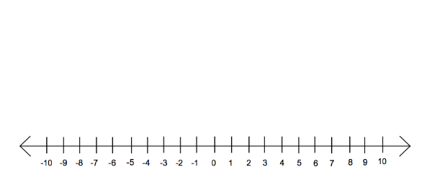

**Questions:**

**1.** Here is a map of the British Isles.

The temperatures in some places, one night last winter are shown on the map.

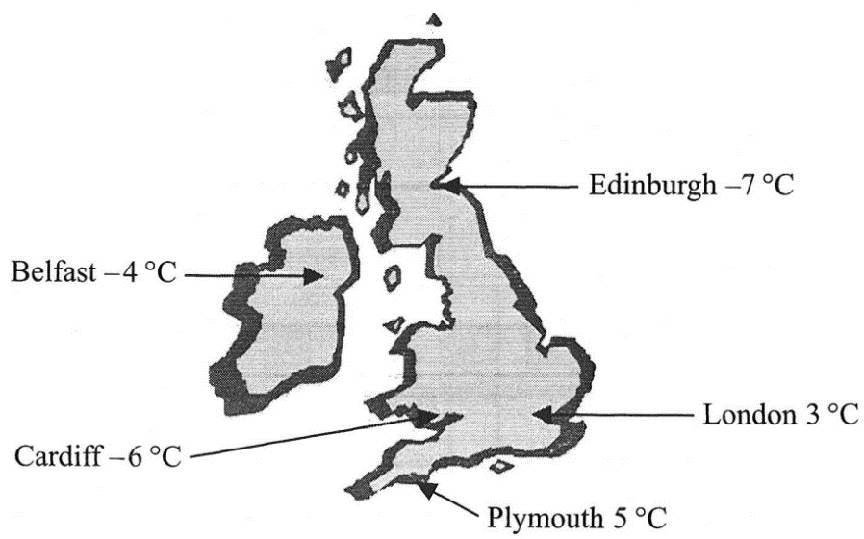

(a) (i) Write down the names of the two places that had the biggest difference in

temperature.

…........................................................

…........................................................

(ii) Work out the difference in temperature between these two places.

….........................°C

**(3)**

(b) Two pairs of places have a difference in temperature of 2 °C.  
Write down the names of these places.

(i) …......................................... and ….............................................

(ii) …......................................... and ….............................................

**(2)**

**(Total 5 marks)**

**2.** Sally wrote down the temperature at different times on 1st January 2003.

|  |  |
| --- | --- |
| **Time** | **Temperature** |
| midnight | – 6 °C |
| 4 am | –10 °C |
| 8 am | – 4 °C |
| noon | 7 °C |
| 3 pm | 6 °C |
| 7 pm | –2 °C |

(a) Write down

(i) the **highest** temperature,

….........................°C

(ii) the **lowest** temperature.

….........................°C

**(2)**

(b) Work out the difference in the temperature between

(i) 4 am and 8 am,

….........................°C

(ii) 3 pm and 7 pm.

….........................°C

**(2)**

At 11 pm that day the temperature had fallen by 5 °C from its value at 7 pm.

(c) Work out the temperature at 11 pm.

….........................°C

**(1)**

**(Total 5 marks)**

**3.** The table shows the temperature on the surface of each of five planets.

|  |  |
| --- | --- |
| **Planet** | **Temperature** |
| Venus | 480 °C |
| Mars | – 60 °C |
| Jupiter | – 150 °C |
| Saturn | – 180 °C |
| Uranus | – 210 °C |

(a) Work out the difference in temperature between Mars and Jupiter.

….........................°C

**(1)**

(b) Work out the difference in temperature between Venus and Mars.

….........................°C

**(1)**

(c) Which planet has a temperature 30 °C higher than the temperature on Saturn?

…........................................................

**(1)**

The temperature on Pluto is 20 °C lower than the temperature on Uranus.

(d) Work out the temperature on Pluto.

….........................°C

**(1)**

**(Total 4 marks)**

**4.** (a) Write down the temperature shown on the thermometer.

….........................°C

**(1)**

The temperature falls by 8°C.

(b) Work out the new temperature.

….........................°C

**(1)**

**(Total 2 marks)**

**5.** The table shows the highest and lowest temperatures one day in London and Moscow.

|  |  |
| --- | --- |
| **Highest** | **Lowest** |
| London | 8°C | –6°C |
| Moscow | –3°C | –8°C |

(a) Work out the difference between the **lowest** temperature in London and the **lowest**temperature in Moscow.

….........................°C

**(1)**

(b) Work out the difference between the **highest** and **lowest** temperature in London.

….........................°C

**(1)**

**(Total 2 marks)**

**6.** The table shows the midday temperatures in 4 different cities on Monday.

|  |  |
| --- | --- |
| **City** | **Midday temperature (°C)** |
| Belfast | 5 |
| Cardiff | –1 |
| Glasgow | –6 |
| London | –4 |

(a) Which city had the lowest temperature?

…........................................................

**(1)**

(b) Work out the difference between the temperature in Cardiff and the temperature in Belfast.

….........................°C

**(1)**

By Tuesday, the midday temperature in London had risen by 7 °C.

(c) Work out the midday temperature in London on Tuesday.

….........................°C

**(1)**

**(Total 3 marks)**

**7.** Mr Snow stayed some time at the South Pole.

The highest temperature there was –30 °C.  
The lowest temperature there was –57 °C.

(a) Work out the difference between the highest temperature and the lowest temperature at the South Pole.

….........................°C

**(1)**

Mr Snow returned to his house in London.  
The temperature outside his house was –2 °C.  
The temperature inside his house was 12 °C higher.

(b) Work out the temperature inside his house.

….........................°C

**(1)**

**(Total 2 marks)**

**8.** Write these temperatures in order. Start with the lowest temperature.

7ºC –2ºC 10ºC –5ºC 3ºC

…………………………………………………………………………………………………..

**(Total for question = 1 mark)**

**Coordinates**



**Things to remember:**

Along the corridor, up the stairs 🡪 (x,y)

**Questions:**

**1.** (a) Write down the coordinates of the

point *P*.

(…....... , ….......)

**(1)**

(b) (i) On the grid, plot the point

(0, 3). Label the point *Q*.

(ii) On the grid, plot the point

(–2, –3). Label the point *R*.

**(2)**

**(Total 3 marks)**

**2.** (a) Write down the coordinates of the point

(i) *A*,

( ……… , …….. )

(ii) *B*.

( ……… , …….. )

**(2)**

(b) On the grid, mark with a cross (×) the midpoint

of the line *AB*.

**(1)**

**(Total 3 marks)**

**3.** (a) (i) Write down the coordinates of the

point A.

(……………,………….)

(ii) Write down the coordinates of the

point *B.*

(……………,………….)

**(2)**

(b) (i) On the grid, mark the point (6, 4) with

the letter *P.*

(ii) On the grid, mark the point (3, 0) with

the letter *Q.*

**(2)**

**(Total 4 marks)**

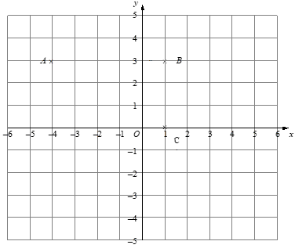**4.** (a) Write down the coordinates of

the point

1. *A*,

(…......... , ….........)

(ii) *C*.

(…......... , ….........)

**(2)**

(b) (i) On the grid, mark the

point *D* so that *ABCD*

is a rectangle.

(ii) Write down the

coordinates of *D*.

(…......... , ….........)

**(2)**

**(Total 4 marks)**

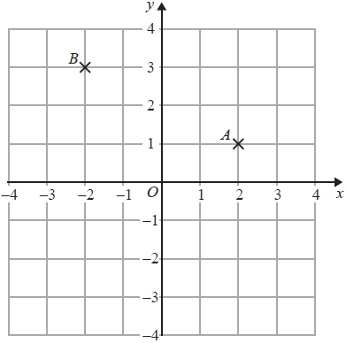**5.** (a)   Write down the coordinates of the point *A*.

(…......... , ….........)

**(1)**

(b)   Write down the coordinates of the point *B*.

(…......... , ….........)

**(1)**

(c)   On the grid, mark with a cross (×) the point

(−3, −1). Label this point *C*.

**(1)**

**(Total for question = 3 marks)**

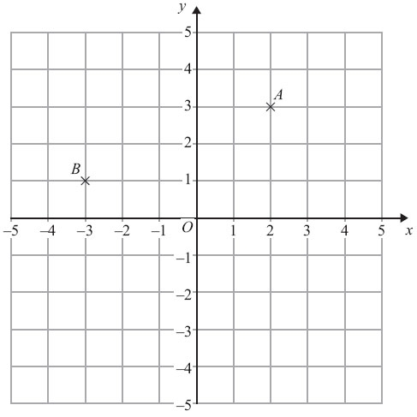

**6.** (a) (i) Write down the coordinates of

the point *A*.

(…......... , ….........)

(ii) Write down the coordinates of

the point *B*.

(…......... , ….........)

**(2)**

(b) On the grid, mark with a cross the

point (3, –4). Label this point *C*.

**(1)**

**(Total for Question is 3 marks)**

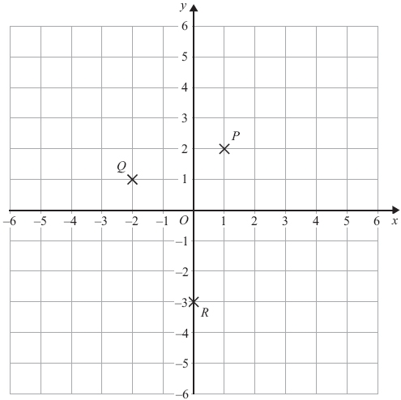**7.** (a) Write down the coordinates of

the point *P*.

(…......... , ….........)

**(1)**

(b) Write down the coordinates of

the point *R*.

(…......... , ….........)

**(1)**

*P*, *Q* and *R* are three vertices of a

parallelogram.

(c) Write down the coordinates of

the fourth vertex of this

parallelogram.

(…......... , ….........)

**(1)**

**(Total for Question is 3 marks)**

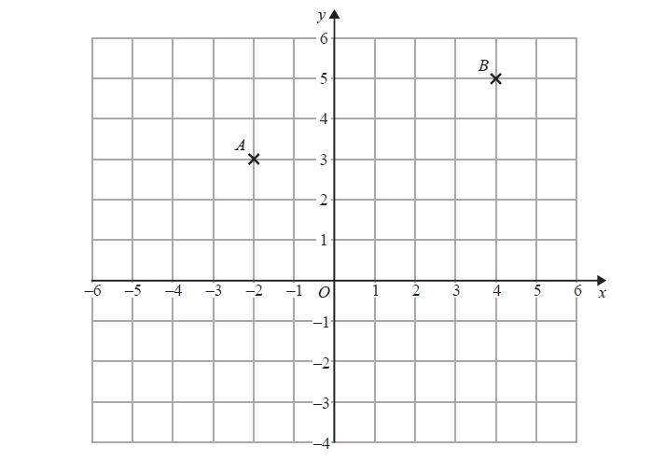

**8.** (a)   Write down the coordinates of

point *B*.

(…......... , ….........)

**(1)**

(b)   Find the coordinates of the

midpoint of *AB*.

(…......... , ….........)

**(1)**

**(Total for question = 2 marks)**

**Patterns and Sequences**

**Things to remember:**

* If there is a pattern, look carefully at how many sticks/blocks are being added on each time.
* Work out the rule (for example: add 4 or multiply by 2) to help you work out the next term.

**Questions:**

**1.** Here are some patterns made from sticks.

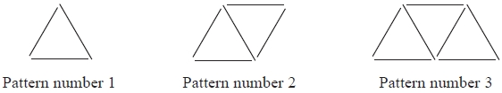

In the space below, draw Pattern number 4

**(1)**

(b) Complete the table.

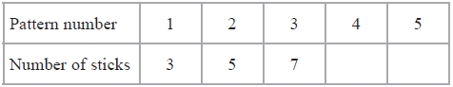

**(1)**

(c) How many sticks make Pattern number 15?

…........................................................

**(1)**

**(Total for Question is 3 marks)**

**2.** Here are the first four terms of a number sequence.

|  |  |  |  |
| --- | --- | --- | --- |
| 6 | 10 | 14 |  |

(a) Write down the next term in this sequence.

…........................................................

**(1)**

(b) Find the 10th term in this sequence.

…........................................................

**(1)**

(c) The number 101 is **not** a term in this sequence. Explain why.

…..................................................................................................................................

…..................................................................................................................................

**(1)**

**(Total for Question is 3 marks)**

**3.** Here are the first four terms of a number sequence.

3     7     11      15

(a) Write down the next term of this sequence.

…........................................................

**(1)**

The 50th term of this number sequence is 199

(b) Write down the 51st term of this sequence.

…........................................................

**(1)**

The number 372 is **not** a term of this sequence.

(c) Explain why.

…..................................................................................................................................

…..................................................................................................................................

**(1)**  
**(Total for Question is 3 marks)**

**4.** Here are some patterns made from white centimetre squares and grey centimetre squares.

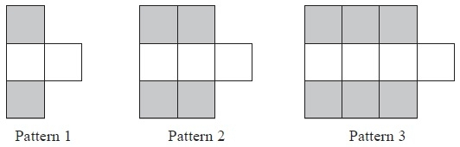

(a)   In the space below, draw Pattern 4

**(1)**

(b)   Find the number of grey squares in Pattern 6

…........................................................

**(1)**

A Pattern has 20 grey squares.

(c)  Work out how many white squares there are in this Pattern.

…........................................................

**(2)**

**(Total for Question is 4 marks)**

**5.** Here are some patterns made from sticks.

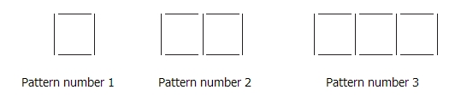

(a) Draw Pattern number 4 in the space below.

**(1)**

(b) How many sticks are needed for Pattern number 12?

…........................................................

**(2)**

Sunil says that he will need 70 sticks for Pattern number 20

(c) Is Sunil correct? You must give a reason for your answer.

…..................................................................................................................................

…..................................................................................................................................

…..................................................................................................................................

**(2)**

**(Total for Question is 5 marks)**

**6.** Here are the first 6 terms of a number sequence.

5 9 13 17 21 25

(a) Write down the next term of the sequence.

…........................................................

**(1)**

(b) (i) Work out the eleventh term of the sequence.

…........................................................

(ii) Explain how you found your answer.

…........................................................................................................................

…........................................................................................................................

…........................................................................................................................

**(2)**

**(Total for Question is 3 marks)**

**7.** Here is a sequence of patterns made with grey square tiles and white square tiles.

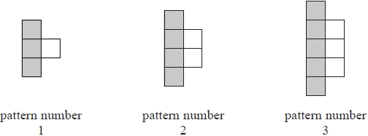

(a) In the space below, draw pattern number 4

**(1)**

(b)   Find the total number of tiles in pattern number 20

…........................................................

**(2)**

**(Total for question is 3 marks)**

**8.** Here is a sequence of patterns made from sticks.

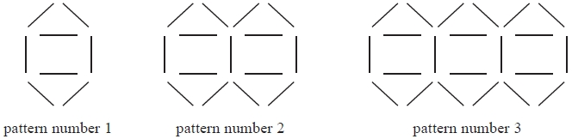

(a) In the space below, draw pattern number 4

**(1)**

(b)   How many sticks are needed for pattern number 10?

…........................................................

**(2)**

**(Total for question = 3 marks)**

**Collecting Like Terms (Simplifying)**

**Things to remember:**

* 2a means a + a or 2 lots of a
* a² means a x a
* The sign (+ or -) belongs to the term following it. You may find it easier to identify like terms using two different highlighters.

**Questions:**

**1.** (a) Simplify *a + a + a + a*

…........................................................

**(1)**

(b) Simplify 3 × *c* × *d*

…........................................................

**(1)**

(c) Simplify 3*ef* + 5*ef* – *ef*

…........................................................

**(1)**

**(Total for Question is 3 marks)**

**2.** (a)   Simplify    *b* + *b* + *b* + *b*

…........................................................

**(1)**

(b)   Simplify    8*n* – 3*n*

…........................................................

**(1)**

(c)   Simplify    3 × *c* × *d*

…........................................................

**(1)**

(d)   Simplify    3*x* + 7*y* + 2*x* – *y*

…........................................................

**(2)**

**(Total for Question is 5 marks)**

**3.** Simplify        3*x* + 5*y* + *x* + 4*y*

…........................................................

**(Total for Question is 2 marks)**

**4.** (a)   Simplify     *a* × *c* × 3

…........................................................

**(1)**

(b)   Simplify     *p* × *p* × *p*

…........................................................

**(1)**

(c)   Simplify     5*x* – 4*y* + 3*x* – 3*y*

…........................................................

**(2)**  
**(Total for Question is 4 marks)**

**5.** (a) Simplify   5*a* – 2*a*

…........................................................

**(1)**

(b) Simplify   3 × 4*y*

…........................................................

**(1)**

(c) Simplify   3*e* + 4*f* + 2*e* – *f*

…........................................................

**(2)**  
**(Total for Question is 4 marks)**

**6.** (a)   Simplify     *m* + *m* + *m*

…........................................................

**(1)**

(b)   Simplify     9*e* – 2*e*

…........................................................

**(1)**

(c)   Simplify     5 × 3*g*

…........................................................

**(1)**  
**(Total for Question is 3 marks)**

**7.** (a)   Simplify     *d* + *d* + *d* + *d*

…........................................................

**(1)**

(b)   Simplify     3 × *e* × *f*

…........................................................

**(1)**

(c)   Simplify     2*x* + 3*y* + 3*x* – *y*

…........................................................

**(2)**

**(Total for question = 4 marks)**

**8.** (a) Simplify    *f* + *f* + *f* + *f* – *f*

…........................................................

**(1)**

(b) Simplify    2*m* × 3

…........................................................

**(1)**

(c) Simplify    3*a* + 2*h* + *a* + 3*h*

…........................................................

**(2)**

**(Total for Question is 4 marks)**

**Solving Linear Equations**

**Things to remember:**

* “Solve” means to find the value of the variable (what number the letter represents).
* The inverse of + is – and the inverse of x is ÷
* Work one step at a time, keeping you = signs in line on each new row of working.

**Questions:**

**1.** A two step function machine is shown.



(a) When the input is -4, what is the output?

…........................................................

**(1)**

(b) If the output is 25, what was the input?

…........................................................

**(1)**

(c) If the input is n, what is the output?

…........................................................

**(2)**

**(Total for Question is 4 marks)**

**2.** You can use this rule to work out the total cost of hiring a car.

|  |
| --- |
| **Total cost = £4 per hour plus £12** |

Arun hires a car for 5 hours.

(a) Work out the total cost.

£…........................................................

**(2)**

Raj hires a car.  
 The total cost is £40

(b) Work out how many hours Raj hires the car for.

…........................................................ hours

**(3)**

**(Total for Question is 5 marks)**

**3.** (a) Solve 6*g* = 18

*g* = . . . . . . . . . . . . . . . . . .

**(1)**

(b) Solve 5*h* + 7 = 17

*h* = . . . . . . . . . . . . . . . . . .

**(2)**

**(Total for Question is 3 marks)**

**4.** (a) Solve   *x* + 9 = 19

*x* = . . . . . . . . . . . . . . . . . .

**(1)**

(b) Solve   2*y* = 17

*y* = . . . . . . . . . . . . . . . . . .

**(1)**

(c) Solve   *w*⁄4= 8

*w* = . . . . . . . . . . . . . . . . . .

**(1)**

**(Total for Question is 3 marks)**

**5.** (a) Solve  = 2

*n* = . . . . . . . . . . . . . . . . . .

**(1)**

(b)   Solve 3*g* + 4 = 19

*g* = . . . . . . . . . . . . . . . . . .

**(2)**

**(Total for Question is 3 marks)**

**6.** (a)   Solve 4*x* = 20

*x* = . . . . . . . . . . . . . . . . . .  
**(1)**

(b) Solve *y* − 9 = 17

*y* = . . . . . . . . . . . . . . . . . .  
**(1)**

**(Total for question = 2 marks)**

**7.** Solve     3*x* + 7 = 1

*x* = . . . . . . . . . . . . . . . . . .  
 **(Total for question = 2 marks)**

**8.** Solve 4*x* + 5 = *x* + 26

*x* = . . . . . . . . . . . . . . . . . .  
**(Total for question = 2 marks)**

**Inequalities**

**Things to remember:**

* < means less than
* > means greater than
* ≤ means less than or equal to
* ≥ means greater than or equal to
* An integer is a whole number
* On a number line, use a full circle to show a value can be equal, and an empty circle to show it cannot.

**Questions:**  
**1.** –2 < *n*  ≤ 3

*n* is an integer.

Write down all the possible values of *n*.

…........................................................

**(Total for Question is 2 marks)**

**2.** (a)   *n* is an integer.

–1 ≤ *n* < 4

List the possible values of *n*.

…........................................................

**(2)**

(b)



Write down the inequality shown in the diagram.

…........................................................

**(2)**

**(Total for Question is 4 marks)**

**3.** Here is an inequality, in *x*, shown on a number line.



Write down the inequality.

…........................................................

**(Total for Question is 2 marks)**

**4.**



(a)   Write down the inequality represented on the number line.

…........................................................

**(1)**

(b) −3 ≤ *n* < 2

−2 < *m* < 4   
*n* and *m* are integers.

Given that *n* = *m*, write down all the possible values of *n*.

…........................................................

**(2)**  
 **(Total for question = 5 marks)**

**5.** −5 < *y* ≤ 0

*y* is an integer.

Write down all the possible values of *y*.

…........................................................

**(Total for Question is 2 marks)**

**6.** (a) *n* is an integer.

–1 ≤ *n* < 4

     List the possible values of *n*.

…........................................................

**(2)**

(b)

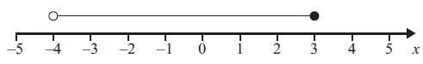

Write down the inequality shown in the diagram.

…........................................................

**(2)**

**(Total for Question is 4 marks)**

**7.** –4 < *n* ≤ 1

*n* is an integer.

(a) Write down all the possible values of *n*.

…........................................................

**(2)**

(b) Write down the inequalities represented on the number line.

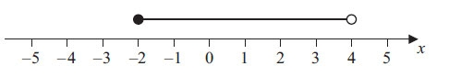

…........................................................

**(2)**

**(Total for Question is 4 marks)**

**8.** –2 < n ≤ 3

Represent this inequality on the number line.



**(Total for Question is 2 marks)**

**Types of Shapes and their Properties**

**Things to remember:**

* Sides and vertices belong on 2D shapes.
* Edges, faces and vertices belong on 3D shapes.

**Questions:**  
**1.** Here is a triangular prism.

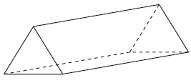

(a) For this prism, write down

(i) the number of edges

...........................................................

(ii) the number of faces

...........................................................

**(2)**

Here is a net of the triangular prism.

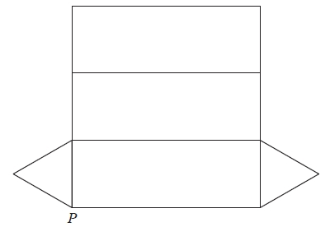

The net is folded to make the prism.   
One other point meets at *P*.

(b) Mark this point on the net with the letter *P*.

**(1)**  
**(Total for Question is 3 marks)**

**2.** Here is a cuboid.

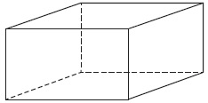

The following sentences are about cuboids.

Complete each sentence by writing the correct number in the gap.

(i)   A cuboid has ................................. faces.

(ii)   A cuboid has ................................. edges.

(iii)   A cuboid has ................................. vertices.

**(Total for Question is 3 marks)**

**3.** (a) On the grid, draw a kite.

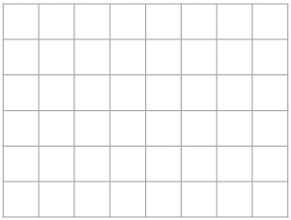

**(1)**

(b) Here is a quadrilateral.

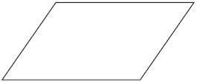

Write down the special name of this quadrilateral.

...........................................................

**(1)**

**(Total for Question is 2 marks)**

**4.** Draw a sketch of a pentagon.

**(Total for Question is 1 marks)**

**5.** Write down the name of each of these 3-D shapes.

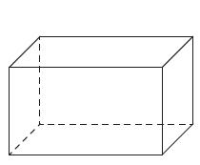 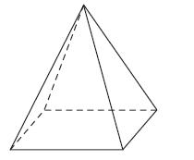

(i) ............................................ (ii) ............................................

**(Total for Question is 2 marks)**

**6.** Here are some solid 3-D shapes.

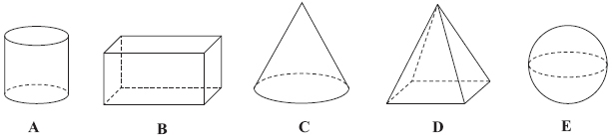

(a) Write down the letter of the shape that is a sphere.

...........................................................

**(1)**

(b) Write down the mathematical name of shape **A**.

...........................................................

**(1)**

(c) How many faces does shape **B** have?

...........................................................

**(1)**

(d) How many edges does shape **D** have?

...........................................................

**(1)**

**(Total for Question is 4 marks)**

**7.** Here are some shapes made from squares.

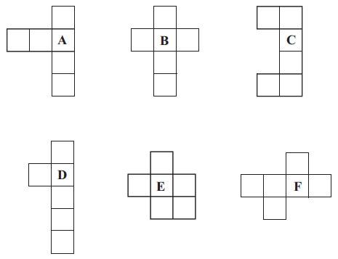

Two of these shapes are nets of a cube.

Which two shapes?

...........................................................

**(Total for Question is 2 marks)**

**8.** Here is a list of the names of five types of quadrilateral.

Trapezium Parallelogram Square Rhombus Rectangle

(a) From the list, write down the names of two quadrilaterals which must have all four

sides the same length.

........................................................... and ...........................................................

**(1)**

(b) From the list, write down the name of the quadrilateral that has only one pair of

parallel sides.

...........................................................

**(1)**

For one of these quadrilaterals: the corners are not right angles,  
            the quadrilateral has rotational symmetry of order 2  
 and    the diagonals cross at right angles.

(c) Write down the name of this quadrilateral.

...........................................................

**(1)**

**(Total for Question is 3 marks)**

**Reflection, Rotation and Symmetry**

**Things to remember:**

* A reflection is where the shape is flipped.
* A rotation is where the shape is turned.

**Questions:**  
**1.** Here is a shaded shape on a grid of centimetre squares.

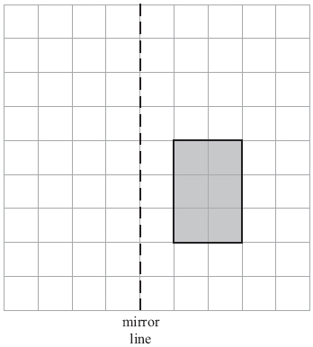

Reflect the shaded shape in the mirror line.

**(Total for Question is 2 marks)**

**2.** (a) On the grid, shade in one more square so that the completed shape has one line of

symmetry.

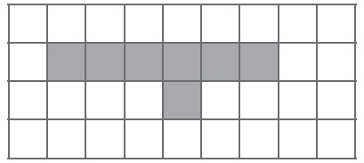

**(1)**

(b) On the grid below, shade in two more squares so that the completed shape has

rotational symmetry of order 2

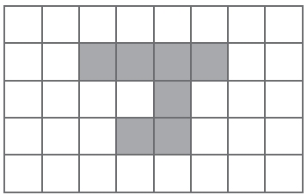

**(1)**

**(Total for Question is 2 marks)**

**3.** (a) Shade **one** more square to make a pattern with 1 line of symmetry.

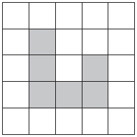

**(1)**

(b) Shade **one** more square to make a pattern with rotational symmetry of order 2

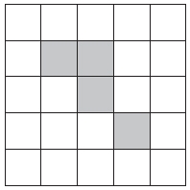

**(1)**

**(Total for Question is 2 marks)**

**4.** Reflect the shaded shape in the mirror line.

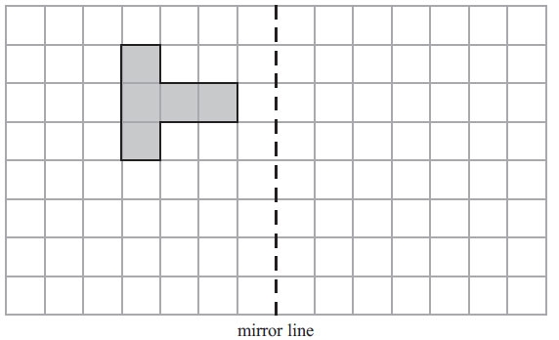

**(Total for Question is 2 marks)**

**5.** Here is an equilateral triangle.

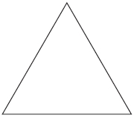

Write down the order of rotational symmetry of the triangle.

…………………………………..

**(Total for Question is 1 mark)**

**6.** (a)   Reflect the shaded shape in the mirror line.

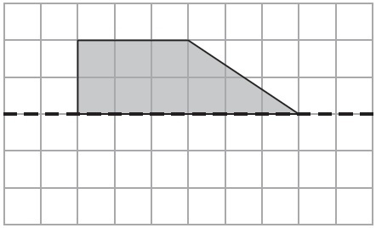

**(1)**

(b)   Reflect the shaded shape in the mirror line.

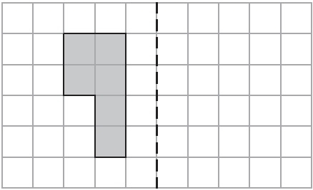

**(1)**

**(Total for Question is 2 marks)**

**7.** On the grid, rotate shape **A** 180° about the point (1, 1).

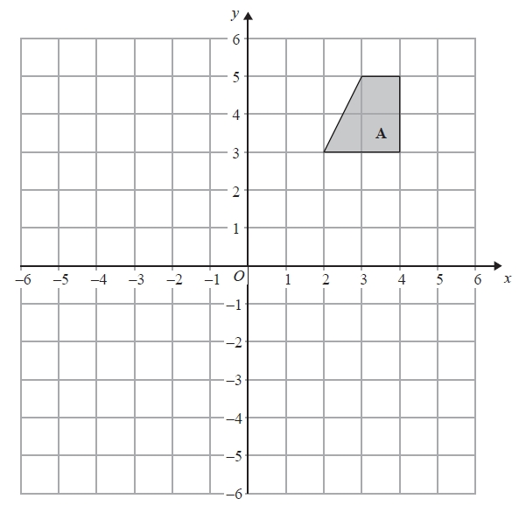

**(Total for Question is 2 marks)**

**8.** (a)   (i)   Shade 4 sectors on diagram **A** so that it has rotational symmetry of order 4

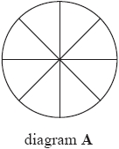

(ii)   Shade 4 sectors on diagram **B** so that it has rotational symmetry of order 2

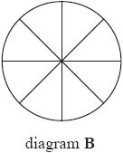

**(Total for question = 2 marks)**

**Area and Perimeter of Rectangles and Triangles**

**Things to remember:**

* Area of a rectangle = base x height
* Area of a triangle = ½ x base x height
* The perimeter is the distance around the outside of shape

**Questions:**

**1.** On the centimetre grid, draw a rectangle with an area of 12 cm2.

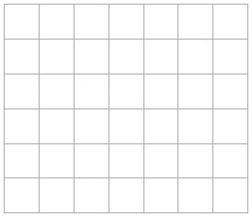

**(Total for Question is 2 marks)**

**2.** On the grid of centimetre squares, draw a rectangle with a perimeter of 10 cm.



**(Total for Question is 2 marks)**

**3.** Here is a rectangle. Work out the area of this rectangle.

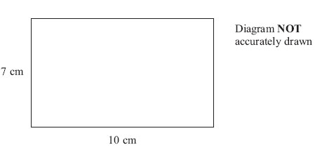

…........................................................ cm2

**(Total for Question is 2 marks)**

**4.** The shaded shape is drawn on a grid of centimetre squares.

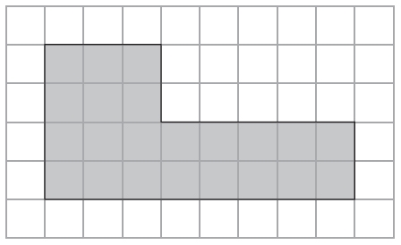

(a) Find the perimeter of the shaded shape.

…........................................................ cm

**(1)**

(b) Find the area of the shaded shape.

…........................................................ cm2

**(1)**

**(Total for Question is 2 marks)**

**5.** The shaded shape is drawn on a grid of centimetre squares.

(a) Find the perimeter of the shaded shape.

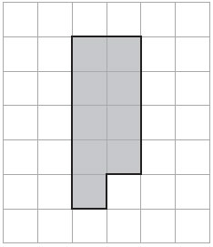

…........................................................ cm

**(2)**

(b) On the grid below, draw a square with the same area as the shaded shape.

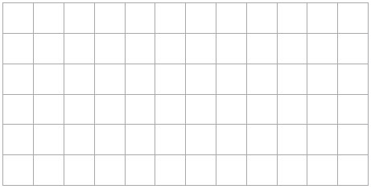

**(1)**

**(Total for Question is 3 marks)**

**6.** Dilys buys a new house.

She wants to have a lawn in the back garden.  
The lawn is going to be in the shape of a rectangle.

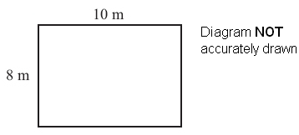

The lawn will have a length of 10 m. The lawn will have a width of 8 m.

Dilys wants to buy edging strip for her lawn.  
The length of the edging strip needs to be equal to the perimeter of her lawn.  
Edging strip costs £1.50 per metre. What is the total cost of the edging strip?

£…........................................................

**(Total for Question is 4 marks)**

**7.** The diagram shows a garden with 4 flower beds.   
The garden is a rectangle, 23 m by 17 m.

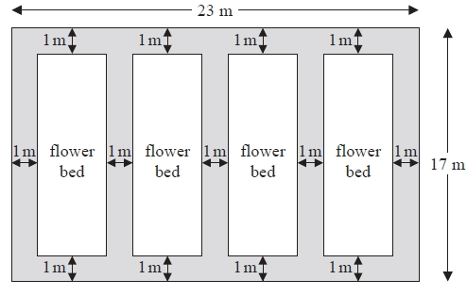

Diagram NOT accurately drawn  
Each flower bed is a rectangle with the same length and the same width.

Work out the length and the width of a flower bed.

length =...........................................................m

width =...........................................................m  
**(Total for Question is 3 marks)**

**8.** The diagram shows a rectangle and a square.

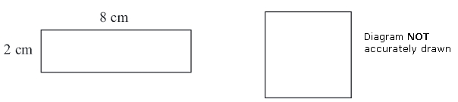

The perimeter of the rectangle is the same as the perimeter of the square.

Work out the length of one side of the square.

…........................................................ cm

**(Total for Question is 4 marks)**

**Measures**

**Things to remember:**

* There are 60 seconds in a minute and 60 minutes in an hour.
* Be careful when reading scales – continue to count on until you reach the next written value to check.

**Questions:**  
**1.** Here is a clock in a school.

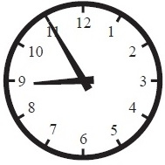

(a)   (i)   School starts 15 minutes earlier than the time shown on the clock.

What time does school start?

...........................................................

(ii)   The first lesson ends 45 minutes after the time shown on the clock.

What time does the first lesson end?

...........................................................

**(2)**

(b)  School finishes at 3.20 pm. Write 3.20 pm using the 24-hour clock.

...........................................................

**(1)**

**(Total for Question is 3 marks)**

**2.** (a) How many minutes are there between 8.50 pm and 10.05 pm?

........................................................... minutes

**(1)**

(b) (i) Write 15 25 using the 12-hour clock.

...........................................................

(ii) Write 9.15 pm using the 24-hour clock.

...........................................................

**(2)**

Lucy and Saad went to a cafe on the same day.

Lucy was in the cafe from 10.15 am to 10.45 am.  
Saad was in the cafe from 10.25 am to 11.05 am.

(c) Work out the number of minutes that Lucy and Saad were in the cafe at the same

time.

........................................................... minutes

**(2)**

**(Total for Question is 5 marks)**

**3.** Complete this table. Write a sensible unit for each measurement.

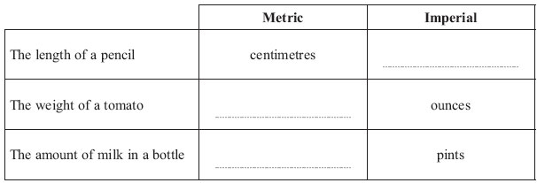

**(Total for Question is 3 marks)**

**4.** (a)   Complete this table. Write a sensible unit for each measurement.

|  |  |  |
| --- | --- | --- |
|  | **Metric** | **Imperial** |
| **Diameter of a football** | ………………………….. | inches |
| **Amount of fuel in a car fuel tank** | litres | ………………………….. |

**(2)**

  (b)  (i) Change 4 kg to grams.

........................................................... grams

  (ii) Change 3500 ml to litres.

........................................................... litres

**(2)**

**(Total for Question is 4 marks)**

**5.** (a)   Write 3 metres in centimetres.

........................................................... centimetres

**(1)**

(b)   Write 4000 grams in kilograms.

........................................................... kilograms

**(1)**

(c)   Write 700 millilitres in litres.

........................................................... litres

**(1)**

**(Total for question = 3 marks)**

**6.** The diagram shows a temperature gauge.

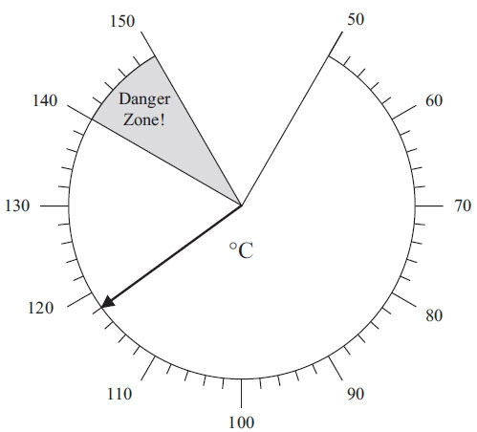

How many degrees does the temperature have to rise to get to the danger zone?

........................................................... °C

**(Total for Question is 2 marks)**

**7.** The diagram shows the speed of a car.

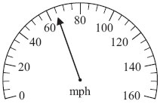

(a) Write down the speed.

........................................................... mph

**(1)**

The diagram shows two boxes on some scales.

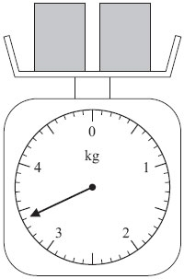

Each box has the same weight.

(b) Work out the weight of each box.

........................................................... kg

**(2)**

**(Total for Question is 3 marks)**

**8.** The diagram shows the temperature in an oven.

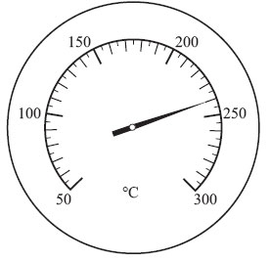

(a) Write down the temperature.

........................................................... °C

**(1)**

(b) On the diagram below, draw an arrow to show a temperature of 125°C.

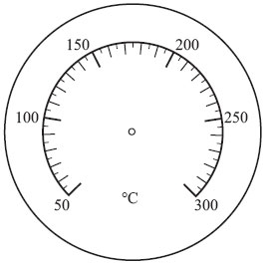

**(1)**

Lorna switches her oven on at 5.50 pm.   
She sets the temperature at 180°C.   
It takes 15 minutes for the oven to reach a temperature of 180°C.

(c) What time will the oven reach a temperature of 180°C?

...........................................................

**(1)**

**(Total for Question is 3 marks)**

**Averages**

**Things to remember:**

* Mode is most – the number that occurs the most frequently.
* Median is middle – put the numbers in order then identify the middle number.
* Mean is mean to work out – add all the numbers together and divide by the quantity in the list.
* Range is the difference from the biggest to the smallest.

**Questions:**

**1.** Chloe made a list of her homework marks.

4 5 5 5 4 3 2 1 4 5

(a) Write down the mode of her homework marks.

…………………….

**(1)**

(b) Work out her mean homework mark.

…………………….

**(2)**

**(Total 3 marks)**

**2.** Peter rolled a 6-sided dice ten times.  
Here are his scores.

3 2 4 6 3 3 4 2 5 4

(a) Work out the median of his scores.

.................................

**(2)**

(b) Work out the mean of his scores.

.................................

**(2)**

(c) Work out the range of his scores.

.................................

**(1)**

**(Total 5 marks)**

**3.** Mr Smith kept a record of the number of absences for each student in his class for one term.

Here are his results.

0 0 0 8 4 5 5 3 2 1

(a) Write down the mode.

………………...

**(1)**

(b) Work out the mean.

………………...

**(2)**

**(Total 3 marks)**

**4.** Here are ten numbers.

7 6 8 4 5 9 7 3 6 7

(a) Work out the range.

.....................................

**(2)**

(b) Work out the mean.

.....................................

**(2)**

**(Total 4 marks)**

**5.** Here are the test marks of 6 girls and 4 boys.

Girls: 5 3 10 2 7 3

Boys: 2 5 9 3

(a) Write down the mode of the 10 marks.

……………………………

**(1)**

(b) Work out the median mark of the **boys**.

……………………

**(2)**

(c) Work out the range of the **girls’** marks.

……………………

**(1)**

(d) Work out the mean mark of all 10 students.

……………………

**(2)**

**(Total 6 marks)**

**6.** Here are 10 numbers.

3 2 5 4 2 4 6 2 1 2

Find the mode of these numbers.

……………….

**(Total 1 mark)**

**7.** Jalin wrote down the ages, in years, of seven of his relatives.

45, 38, 43, 43, 39, 40, 39

(a) Find the median age.

.......................................

**(1)**

(b) Work out the range of the ages.

.......................................

**(1)**

(c) Work out the mean age.

.......................................

**(2)**

**(Total 4 marks)**

Tally Charts and Bar Graphs

Things to remember:

* The fifth tally mark should make a gate – this makes it easier to count the tally as you can count up in 5s.
* Frequency means total.
* If you are drawing a bar chart, the axes must be labelled.

**Questions:**

**1.** Ray and Clare are pupils at different schools. They each did an investigation into their teachers’ favourite colours. Here is Ray’s bar chart of his teachers’ favourite colours.



(a) Write down two things that are wrong with Ray’s bar chart.

…………………………………………………………………………………………………..

…………………………………………………………………………………………………..

**(2)**

Clare drew a bar chart of her teachers’ favourite colours. Part of her bar chart is shown below.



4 teachers said that Yellow was their favourite colour.  
2 teachers said that Green was their favourite colour.

(b) Complete Clare’s bar chart.

**(2)**

(c) Which colour was the mode for the teachers that Clare asked?

.....................................

**(1)**

(d) Work out the number of teachers Clare asked.

.....................................

**(1)**

(e) Write down the fraction of the number of teachers that Clare asked who said Red was their favourite colour.

.....................................

**(1)**

**(Total 7 marks)**

**2.** A shop has a sale.The bar chart shows some information about the sale.



The normal price of a vacuum cleaner is £80  
The sale price of a vacuum cleaner is £60  
The price of a vacuum cleaner is reduced from £80 to £60

(a) Find the reduction in the price of the iron.

£ .......................

**(1)**

(b) Which two items have the same sale price?

........................................ and ........................................

**(1)**

(c) Which item has the greatest reduction in price?

.........................................

**(1)**



(d) Complete the bar chart for the mixer and the fryer.

**(2)**

**(Total 7 marks)**

**3.** Daniel carried out a survey of his friends’ favourite flavour of crisps.

Here are his results.

Plain Chicken Bovril Salt & Vinegar Plain

Salt & Vinegar Plain Chicken Plain Bovril

Plain Chicken Bovril Salt & Vinegar Bovril

Bovril Plain Plain Salt & Vinegar Plain

(a) Complete the table to show Daniel’s results.

|  |  |  |
| --- | --- | --- |
| Flavour of crisps | Tally | Frequency |
| Plain |  |  |
| Chicken |  |  |
| Bovril |  |  |
| Salt & Vinegar |  |  |

**(3)**

(b) Write down the number of Daniel’s friends whose favourite flavour was Salt & Vinegar.

……………………..

**(1)**

(c) Which was the favourite flavour of most of Daniel’s friends?

……………………..

**(1)**

**(Total 5 marks)**

**4.** Here is a bar chart showing the number of hours of TV that Helen and Robin watched last week.



(a) Write down the number of hours of TV that Helen watched on Monday.

………………………hours

**(1)**

(b) On which day did Helen and Robin watch the same number of hours of TV?

………………………

**(1)**

(c) (i) Work out the total number of hours of TV that Robin watched on Friday and

Saturday.

………………………hours

(ii) Who watched the greater number of hours of TV on Friday and Saturday?

Show your working.

**(3)**

**(Total 5 marks)**

**5.** Heather carried out a survey about her friends’ pets. Here are her results.

Cat Cat Dog Hamster Cat

Dog Hamster Cat Cat Dog

Hamster Dog Hamster Dog Fish

Cat Dog Fish Cat Cat

Complete the table to show Heather’s results.

|  |  |  |
| --- | --- | --- |
| Pet | Tally | Frequency |
| Cat |  |  |
| Dog |  |  |
| Fish |  |  |
| Hamster |  |  |

**(Total 3 marks)**

**Pictograms**

**Things to remember:**

* Use the key!
* Once you have the number the whole pictures represents you can work out what the picture would be to represent 1 or 2 etc.

**Questions:**

**1.** The pictogram shows the numbers of loaves of bread made by Miss Smith, Mr Jones and  
Mrs Gray.

|  |  |
| --- | --- |
| Miss Smith |  |
| Mr Jones |  |
| Mrs Gray |  |
| Ms Shah |  |
| Mr Khan |  |

 represents 20 loaves of bread

(a) Write down the number of loaves of bread made by Mr Jones.

.....................

**(1)**

(b) Write down the number of loaves of bread made by Mrs Gray.

.....................

**(1)**

Ms Shah made 60 loaves of bread.  
Mr Khan made 90 loaves of bread.

(c) Use this information to complete the pictogram.

**(2)**

**(Total 4 marks)**

**2.** The pictogram gives information about the number of goals scored in a local football  
league in each of 3 weeks.

|  |  |
| --- | --- |
| First week |  |
| Second week |  |
| Third week |  |
| Fourth week |  |
| Fifth week |  |

Key:  represents 4 goals

(a) Find the number of goals scored in the first week.

………………...

**(1)**

(b) Find the number of goals scored in the third week.

………………...

**(1)**

8 goals were scored in the fourth week.  
5 goals were scored in the fifth week.

(c) Complete the pictogram.

**(2)**

**(Total 4 marks)**

**3.** Sharif buys some fruit. The pictogram shows information about the number of apples and the number of oranges he buys.



(a) Write down the number of apples he buys.

....................................

**(1)**

(b) Write down the number of oranges he buys.

....................................

**(1)**

Sharif buys 12 peaches.

(c) Use this information to complete the pictogram.

**(1)**

**(Total 3 marks)**

**Probability**

**Things to remember:**

* Probability can be expressed as a fraction, decimal or percentage. Do not write it as a ratio.
* All probabilities of an event will add up to 1.

**Questions:**

**1.** Draw a circle around the word, or words, which best describe the following possibilities.

(a) It will rain in Manchester next September.

|  |
| --- |
| impossible unlikely even chance likely certain |

**(1)**

(b) The next baby to be born in London will be a girl.

|  |
| --- |
| impossible unlikely even chance likely certain |

**(1)**

**(Total 2 marks)**

**2.** On the probability scale below, mark

(i) with the letter S, the probability that it will snow in London in June,

(ii) with the letter H, the probability that when a fair coin is thrown once it comes down heads,

(iii) with the letter M, the probability that it will rain in Manchester next year.

|  |  |
| --- | --- |
|  |  |

1. 1

**(Total 3 marks)**

**3.** Kevin buys one raffle ticket.  
A total of 350 raffle tickets are sold.  
One of these tickets will win the raffle.  
Each ticket has an equal chance of winning the raffle.

Write down the probability that Kevin’s ticket will win the raffle.

…………………………..

**(Total 1 mark)**

**4.** The diagram shows a fair spinner in the shape of a rectangular octagon.



The spinner can land on A or B or C. Marc spins the spinner.

Write down the probability that the spinner will land on A.

.............................

**(Total 2 marks)**

**5.** A bag contains some beads which are red or green or blue or yellow.

The table shows the number of beads of each colour.

|  |  |  |  |  |
| --- | --- | --- | --- | --- |
| Colour | Red | Green | Blue | Yellow |
| Number of beads | 3 | 2 | 5 | 2 |

Samire takes a bead at random from the bag.  
Write down the probability that she takes a blue bead.

............................

**(Total 2 marks)**

**6.** Richard has a box of toy cars.  
Each car is red or blue or white.

3 of the cars are red. 4 of the cars are blue. 2 of the cars are white.

Richard chooses one car at random from the box.

Write down the probability that Richard will choose a blue car.

……………………

**(Total 2 marks)**

**7.** A company makes hearing aids.

A hearing aid is chosen at random. The probability that is has a fault is 0.09

Work out the probability that a hearing aid, chosen at random, will **not** have a fault.

…………………

**(Total 1 mark)**

**8.** 60 British students each visited one foreign country last week.  
The two-way table shows some information about these students.

|  |  |  |  |
| --- | --- | --- | --- |
| **France** | **Germany** | **Spain** | **Total** |
| **Female** |  |  | 9 | 34 |
| **Male** | 15 |  |  |  |
| **Total** |  | 25 | 18 | 60 |

(a) Complete the two-way table.

**(3)**

One of these students is picked at random.

(b) Write down the probability that the student visited Germany last week.

..........................

**(1)**

**(Total 4 marks)**

**Simplifying Ratios**

**Things to remember:**

* Divide both parts of the ratio by the same factor until in its simplest form.

**Questions:**

**1.** Write the ratio 2 : 6 in its simplest form.

...........................................................

**(1)**

**(Total for Question is 3 marks)**

**2.** Ewen has 48 white tiles and 16 blue tiles.

(a)   Write down the ratio of the number of white tiles to the number of blue tiles.   
Give your ratio in its simplest form.

...........................................................

**(2)**

The cost of each white tile was £2   
The cost of each blue tile was £4

(b)  Work out the ratio of the total cost of the white tiles to the total cost of the blue tiles.

...........................................................

**(2)**

**(Total for question = 4 marks)**

**3.** There are 140 students at Walbridge school.  
80 of the students walk to school.  
60 of the students cycle to school.

Write the ratio of the number of students who walk to school to the number of students who cycle to school.  
Give your ratio in its simplest form.

...........................................................

**(Total for Question is 2 marks)**

**4.** There are only red counters and blue counters in a bag.   
The ratio of the number of red counters to the number of blue counters is 4 : 6

Write this ratio in its simplest form.

...........................................................

**(Total for question = 1 mark)**

**Simplifying Fractions and Fractions of Amounts**

* Divide both the numerator (top) and denominator (bottom) of the fraction by the same factor until in its simplest form.
* To find a fraction of an amount, divide the amount by the denominator, then multiply by the numerator.

**Questions:  
1.** Sam has £480

He spends ¼ of the £480

Work out how much money Sam has left.

£ ...........................................................

**(Total for Question is 3 marks)**

**\*2.** The normal price of a denim shirt at a shop is £9.60

On Special Offer Day, there is  off the normal price.

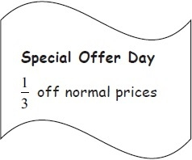

Billy has £13

Has he enough money to buy two denim shirts on Special Offer Day?

You must show all your working.

**(Total for Question is 4 marks)**

**3.** Here is a shape. Shade 3⁄4 of this shape.

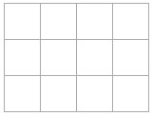

**(Total for Question is 1 mark)**

**4.** (a)   Write down the fraction of this shape that is shaded.

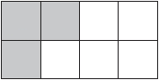

...........................................................

**(1)**

(b)   Shade  of this shape.

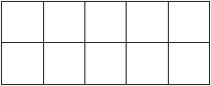

**(1)**

Here are some fractions.



Two of these fractions are equivalent to 

(c)   Which two fractions?

........................................................... and ...........................................................

**(2)**

**(Total for question = 5 marks)**

**\*5.** Here are two fractions.

2⁄3           7⁄8

Which of these fractions has a value closer to 3⁄4?

You must show clearly how you get your answer.

**(Total for Question is 3 marks)**

**6.** Why does ?  
  
 …………………………………………………………………………………………………..

…………………………………………………………………………………………………..

**(Total for Question is 2 marks)**

**7.** (a) What fraction of this shape is shaded?

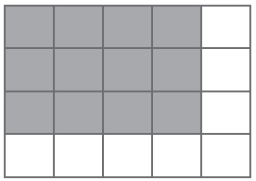

Write your fraction in its simplest form.

...........................................................

**(2)**

(b) Shade 3⁄8 of this shape.

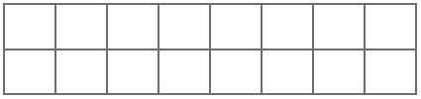

**(1)**

**(Total for Question is 3 marks)**

**8.** Write 35 out of 65 as a fraction.   
Give your fraction in its simplest form.

...........................................................

**(Total for question = 2 marks)**

**Fractions, Decimals and Percentages**

**Things to remember:**

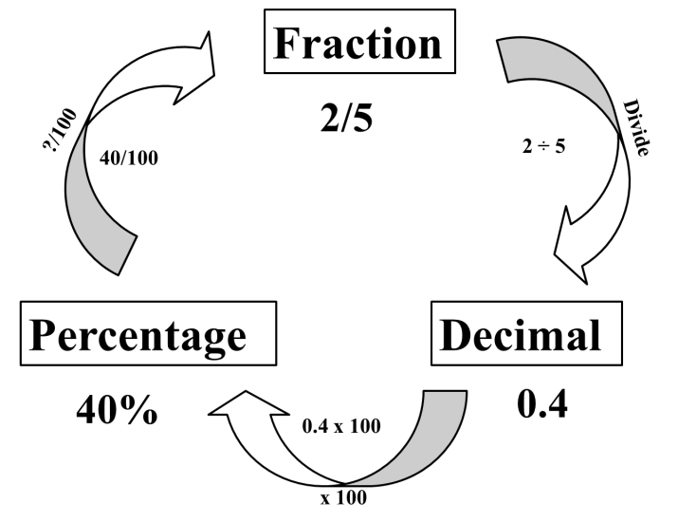

**Questions:**

**1.** (a) Write 0.1 as a fraction.

 ...........................................................

**(1)**

(b) Write ¼ a decimal.

 ...........................................................

**(1)**

**(Total for Question is 2 marks)**

**2.** (a)   Write  as a decimal.

...........................................................

**(1)**

(b)   Write 0.3 as a fraction.

...........................................................

**(1)**

**(Total for Question is 2 marks)**

**3.** (a)   Write  as a decimal.

...........................................................

**(1)**

(b)   Write 0.15 as a fraction.

...........................................................

**(1)**

(c)   Write 17 out of 40 as a fraction.

...........................................................

**(1)**

**(Total for question = 3 marks)**

**4.** (a)   Write 7⁄10 as a decimal.

...........................................................

**(1)**

(b)   Write 0.45 as a percentage.

...........................................................

**(1)**

(c)   Write 30% as a fraction.   
Give your fraction in its simplest form.

...........................................................

**(2)**

**(Total for Question is 4 marks)**

**5.** (a) Write 0.7 as a fraction.

...........................................................

**(1)**

(b) Write 0.3 as a percentage.

...........................................................

**(1)**

(c) Write 8⁄12 in its simplest form.

...........................................................

**(1)**

**(Total for Question is 3 marks)**

**6.** Write these numbers in order of size. Start with the smallest number.



…………………………………………………………………………………………………..

**(Total for question = 2 marks)**

**7.** Write these numbers in order of size. Start with the smallest number.



…………………………………………………………………………………………………..

**(Total for question = 2 marks)**

**8.** Celina and Zoe both sing in a band.   
One evening the band plays for 80 minutes.   
Celina sings for 65% of the 80 minutes.   
Zoe sings for  of the 80 minutes.   
Celina sings for more minutes than Zoe sings.   
Work out for how many more minutes.   
You must show all your working.

........................................................... minutes

**(Total for question = 4 marks)**

**Useful websites:**

**www.methodmaths.com**

**www.hegartymaths.com**

**www.mymaths.co.uk**

**www.drfrost.com**

**www.bbc.co.uk/schools/gcsebitesize**

**/maths**

Remember: Do your best;

it is all you can do ☺