Pinpoint Learning
A guide for students to input their own papers individually
- Login using your personalised login
- Click on ‘enter your marks here’ (orange box)
- Using the drop down menu click on ‘indicate year group’ then ‘practise paper not done under exam conditions’ then enter today’s date when asked for ‘when the test was taken’ and ‘submit’
- Choose your test. E.g 9-1 specification, Edexcel, Practice papers set 1, Paper 1f

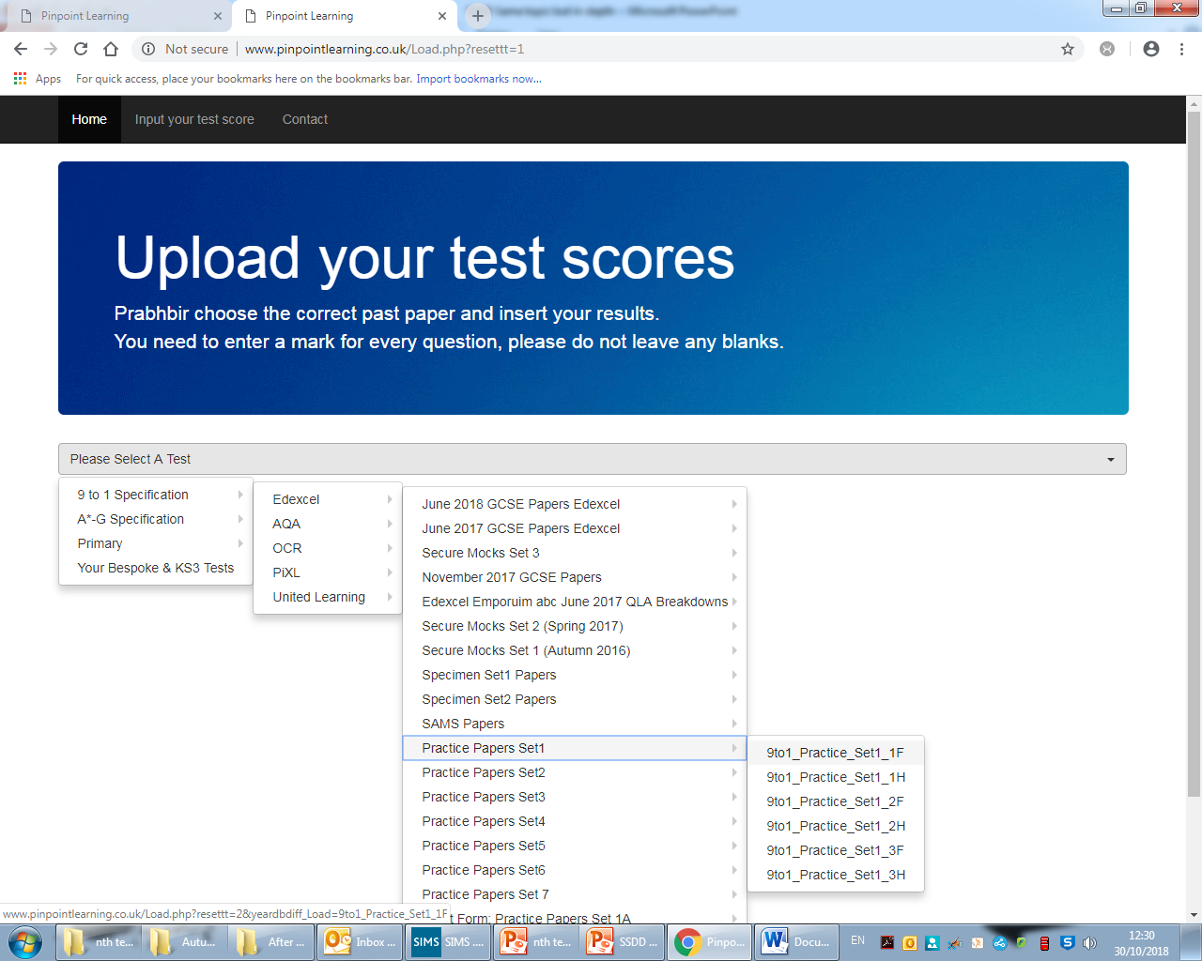

- Fill out the scores for each question and ‘submit’.

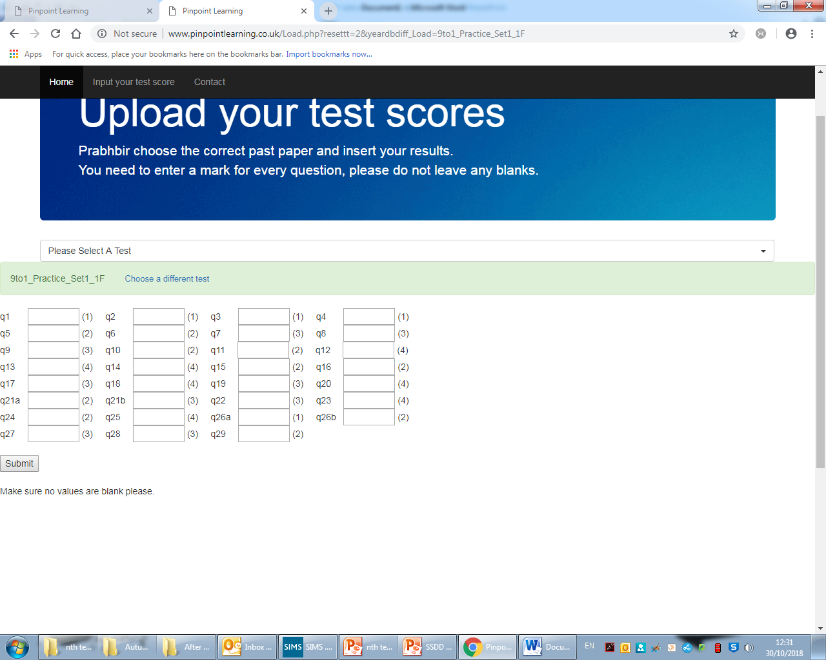

- Once you have pressed submit, you should now see a screen that allows you to produce a booklet, save this in your area- this will always be saved on pinpoint for you to be able to come back to. You can print these and use for revision for PPE

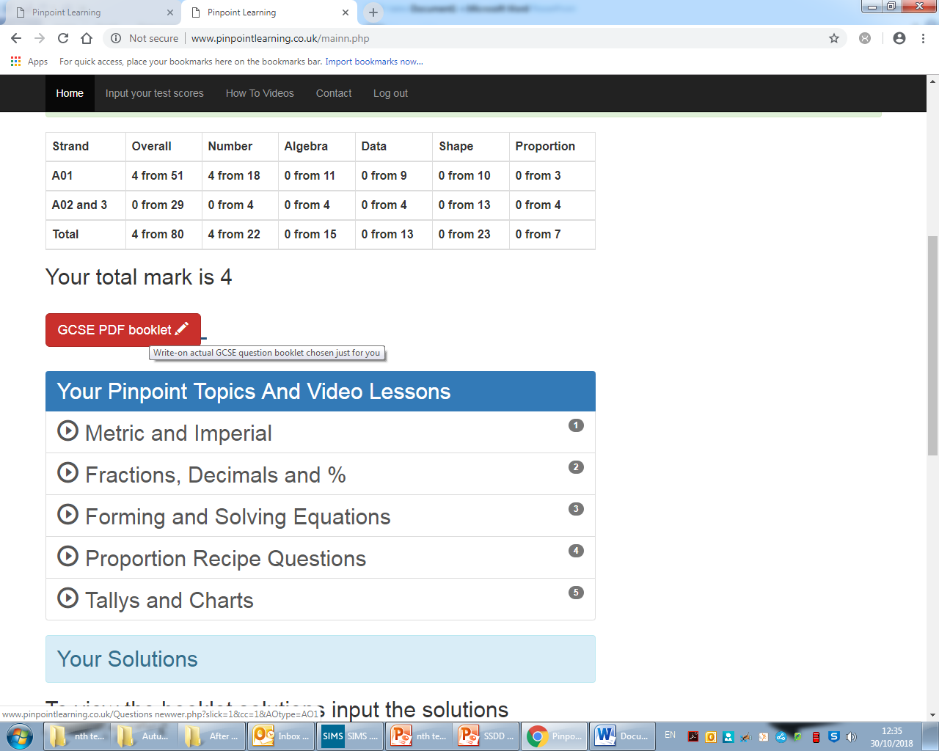

- To input the next test, click on ‘choose a different test’ and repeat steps above.
- If you do not finish during the lesson, you must do this for homework

